**SAS Marketing Automation 5.1**

**Unix Install Instructions for Hot Fix 51MA13**

***Introduction***

This document describes the steps necessary to install and deploy the SAS Marketing Automation 5.1 Hot Fix Release 51MA13 for a Unix environment. ***Please take a moment to read through this entire document before attempting to install the Hot Fix.*** There are six steps to this Hot Fix that must all be completed:

1. Installation of the updates to the SAS Marketing Automation Components
2. Post-configuration and deployment of the SAS Marketing Automation Application Server
3. Post-configuration and deployment of the SAS Customer Intelligence Reporting Application
4. Post-configuration and deployment of the SAS Marketing Automation Web Components update (optional)
5. Install the changes to macros and stored processes on the SAS Compute Server
6. Customer Intelligence Reporting Common Data Model updates

***Fix Details***

The Hot Fix 51MA13 addresses the issue(s) in 5.1 of SAS Marketing Automation software on Windows as documented in the "Issue(s) Addressed" section of the Hot Fix download page:

http://ftp.sas.com/techsup/download/hotfix/ma51.html #51MA13

You may also access SAS Notes from the Technical Support Main page:

<http://support.sas.com/techsup/search/sasnotes.html>

SAS Marketing Automation Hot Fixes are cumulative. Only the latest Hot Fix need be applied to install all fixes. The Hot Fix needs to be applied to all tiers. Servers (Windows and/or Unix) and clients (Windows). Please be sure to use the Hot Fix installer appropriate to the server/client operating system.

Although the actual fixes incorporated in the Hot Fix are cumulative there are changes to the SAS Customer Intelligence Reporting Common Data Model (CDM) which depend on whether or not you have already installed any Hot Fixes. See **Section 7** and **Appendix A** of this document before making any CDM changes.

Please review SAS Note SN-018542, (<http://support.sas.com/kb/18/542.html>) as the Hot Fix install can overwrite the lsfadmin password and prevent campaigns from being directly scheduled from Campaign Studio.

1. ***Obtaining the Hot Fix Bundle***

Save the Hot Fix bundle (archive file) from the SAS Technical Support Hot Fix web site (<http://ftp.sas.com/techsup/download/hotfix/ma51.html> ) to a work directory on the server using the SAS user account that originally installed SAS Marketing Automation. This is typically the ‘sas’ account. The name of the downloaded archive file will vary depending on the Unix platform. The downloaded file will be one of the following:

1. • 51ma13r6.tar for AIX
2. • 51ma13s6.tar for Solaris
3. • 51ma13hx.tar for HP Itanium

There are check boxes included at each step to assist you with verification of the completion of each step as you work through these instructions.

**1.1 Installation**

You should perform these installation steps for *each machine* where the following Marketing Automation components have been installed.

* SAS Customer Intelligence Core Mid-Tier
* SAS Customer Intelligence Web Components
* SAS Customer Intelligence Studio
* SAS Customer Intelligence Plug Ins for SAS Management Console
* SAS Marketing Automation Launcher
* SAS Marketing Automation Integration Utilities
* SAS Customer Intelligence Reporting Mid-Tier
* SAS Marketing Automation Server Processes (macros and stored processes)

Once the Hot Fix has been installed on your Unix servers you will need to download and install the Windows 51MA13 Hot Fix onto all of your client PCs

**1.2 Unarchive the downloaded tar file**

Unarchive the 51ma13xxx tar file using the following command:

tar -xvf 51ma13xxx.tar

where xxx is the appropriate suffix for your unix platform.

This will extract the following files into a new 51ma13_xxx directory. For example, the AIX tar file 51ma13r6.tar will extract into 51ma13_r64. Sample output from the above tar command is shown below. The sizes of the files will vary based on the Unix platform. The sample below shows messages from an AIX tar file extract.

x 51ma13_r64/emaauxdataio_r64.tar, 34672640 bytes

x 51ma13_r64/emacore_r64.tar, 42054960 bytes

x 51ma13_r64/emalauncher_r64.tar, 31641600 bytes

x 51ma13_r64/emasmc_r64.tar, 34713600 bytes

x 51ma13_r64/emawebnport_r64.tar, 34826240 bytes

x 51ma13_r64/custintelmid_r64.tar, 34672640 bytes

x 51ma13_r64/mktautor6.tar, 441344 bytes

You can see from the tar files the following Marketing Automation Components will be updated by this Hot Fix:

1. • Marketing Automation Integration Utilities (emaauxdataio)
2. • Customer Intelligence Core Mid-Tier (emacore)
3. • Marketing Automation Launcher (emalauncher)
4. • Customer Intelligence Plugins to SAS Management Console (emasmc)
5. • Custom,er Intelligence Web Application (emawebnport)
6. • Customer Intelligence Reporting (custintelmid)
7. • Marketing Automation Server Processes (mktauto)

For each component on installed on your server, you’ll need to unarchive the tar file and run the setup script. The files within the component archives are named similarly, so you will need to unarchive and execute the setup scripts one by one.

Sample AIX process shown below:

**Step 1**: Unarchive the component tar file

tar -xvf emaauxdataio_r64.tar

This creates 3 new files in r64 subdirectory:

-rwxr-xr-x 1 sas staff 27813035 Oct 31 10:01 Setup_AIX_Power

-rw-r--r-- 1 sas staff 13 Oct 31 10:01 media.inf

-rw-r--r-- 1 sas staff 7603287 Oct 31 10:01 setup.jar

**Step 2:** Run Setup script to lay down component files.

cd r64

chmod +x Setup*

Setup_AIX_Power

Note that you must turn on the execute bit for the setup script the first time you perform the unarchive.

This setup command runs an InstallShield wizard to lay down the SAS components. A series of three screens will appear by the Installer that you must click through.

**Step 3:**  Repeat steps 1 and 2 (above) for each component except the Marketing Automation Server Processes (mktauto – Section 6 discusses applying the SAS Compute Server changes) until the setup scripts matching the components installed on your server have been run.

**Step 4:** Once InstallShield Components have been run, you can verify the updated files as follows:

**Mid-Tier**

SASMarketingAutomationCore/4.1/Config/emacore_hf.xml (01/29/08)

SASMarketingAutomationCore/4.1/ear/sas.iquery.metadata.jar (06/04/09)

SASMarketingAutomationCore/4.1/ear/sas.iquery.dataservices.jar (06/04/09)

**___ Installation Ran Successfully**

***2. Post-configuration and Deployment of the SAS Marketing Automation Application Server***

**2.1 Download Ant to Run the Post Configuration Script**

Apache Ant is needed to run the post-configuration script for the SAS Marketing Automation Application Server that is included in this Hot Fix. Download and install Ant 1.7 from <http://ant.apache.org/.> See the Apache Ant Documentation for any install details.

Run ant -version from your command prompt and verify that you are accessing ant 1.7

Be sure JAVA_HOME is set correctly with the location of your java installation. Failure to do so will result in errors when running the ant command.

**___ Downloaded ANT and verified the version**

**2.2: Run the Post-configuration Ant script**

The 51MA13 Hot Fix has installed a post-configuration script, emacore_hf.xml, that will repackage sas.analytics.crm.ma.core.ear with the updated code and the deployment descriptor (ejb-jar.xml) that has already been configured for your environment. You will find emacore_hf.xml in the sas installation directory: SASMarketingAutomationCore/4.1/Config/emacore_hf.xml.

Navigate to the bin subdirectory where ant is installed:

**Example: cd /usr/local/ant/apache-ant-1.7.0/bin**

Set JAVA_HOME for session if needed for you specific installation:

**Example: export JAVA_HOME=/usr/java14**

**Stop the SAS Remote Services server before running the ant script.**

Run this command to execute the emacore_hf.xml script (all on one line)

**ant -f emacore_hf.xml**

**-Dconfig.dir=<CONFIGDIR>**

**-Dtemp.dir=<TEMPDIR>**

**-Dinstall.loc=<INSTALL_ DIR>**

where

**<CONFIGDIR>** is the path to the Configuration Directory (eg. /saswork/MAplan) where the new sas.analytics.crm.ma.core.ear files are copied when the Hot Fix is applied by executing the ant scripts.

**<TEMPDIR>** is a path to an **empty** temporary directory for temp files. Make sure this location is empty so that the script can execute without errors when it performs the clean up.

**<INSTALL_DIR>** is the location of the product install (eg. /saswork/SAS/SASMarketingAutomationCore/4.1)

***Helpful hint***: create a .sh file with the command above in case you need to make corrections.

**Example:**

ant -f "/saswork/SAS/SASMarketingAutomationCore/4.1/Config/emacore_hf.xml"

-Dconfig.dir="/saswork/MAplan" -Dtemp.dir="/saswork/hotfix_tmp"

-Dinstall.loc="/saswork/SAS/SASMarketingAutomationCore/4.1"

Final messages from the execution of the script should be similar to:

BUILD SUCCESSFUL

Total time: 11 seconds

**Note**: A complete log from the ant script can be found in the SAS installation directory SASMarketingAutomationCore/4.1/emacore_hf.log.

**___ Successfully executed emacore_hf.xml script**

**Verify core-remote jar and restart RemoteServices**

The ant script will copy an updated sas.analytics.crm.ma.core-remote.jar into the configuration directory  
at Lev1/web/Deployments/RemoteServices/WEB-INF/lib. The new file will have a size of 713489 kb.

Once you verify the jar has been updated, restart your StartRemoteServices.bat script to restart the SAS  
Application Services.

**___ Restart Remote Services**

**2.3: Run the Post-configuration Ant script for Customer Intelligence Reporting**

The 51MA13 Hot Fix has installed a post-configuration script, custintelmid_hf.xml, that will repackage sas.analytics.crm.ma.ccsservice.war with updated code. You will find custintelmid_hf.xml in the SAS installation directory: /saswork/SAS/SASCustomerIntelligenceReporting/5.1/Config. Note this directory will contain a log called custintelmid_hf.log after the execution of this script. As with the previous step, execute the custintelmid_hf.xml script by using Apache Ant.

Open a command window and navigate to the bin subdirectory where ant is installed:

**cd c:\apache-ant-1.7.0\bin**

Run this command to execute the custintelmid_hf.xml script (all on one line)

**ant -f custintelmid_hf.xml**

**-Dconfig.dir=<CONFIGDIR>**

**-Dtemp.dir=<TEMPDIR>**

**-Dinstall.loc=<INSTALL_ DIR>**

***Helpful hint***: create a .bat file with the command above in case you need to make corrections.

**Example:**

ant -f "/saswork/SAS/SASCustomerIntelligenceReporting/5.1/Config/custintelmid_hf.xml"

-Dconfig.dir="/saswork/SAS/MA51Plan" -Dtemp.dir="c:/temphf"

-Dinstall.loc="/saswork/SAS/SASCustomerIntelligenceReporting/5.1"

**Verify sas.analytics.crm.ma.ccsservice.war**

The ant script will copy an updated sas.analytics.crm.ma.ccservice.war into the configuration directory at Lev1/web/webapps. The script will have created a copy of the original war file suffixed with today’s date.

The Customer Intelligence Reporting war module needs to be redeployed in its respective application server (Weblogic or Websphere) for the changes to take effect.

**___ Successfully executed custintelmid_hf.xml script**

**2.4: Deployment of the MA core Jar file**

If you are deploying to **BEA WebLogic**, please now follow the instructions under section 2.4.1: Deployment Instructions for BEA WebLogic.

If you are deploying to **IBM WebSphere**, please now follow the instructions under section 2.4.2: Deployment Instructions for IBM WebSphere.

**2.4.1: Deployment Instructions for BEA WebLogic.**

After logging into the Weblogic console, Navigate to Deployments==> Applications==>MACore sas.analytics.crm.ma.core.jar in the left panel. (Note that your application name may vary. The example below used the name MACore.) Click the Configuration tab to verify your deployment path is the Lev1/web/webapps/exploded directory where the updated jar now resides. (If you used some other path, you’ll need to extract and copy the updated jar.)

Click the 'Deploy' tab at the top of the right window.

Click the 'ReDeploy Applications' button under the Actions column.

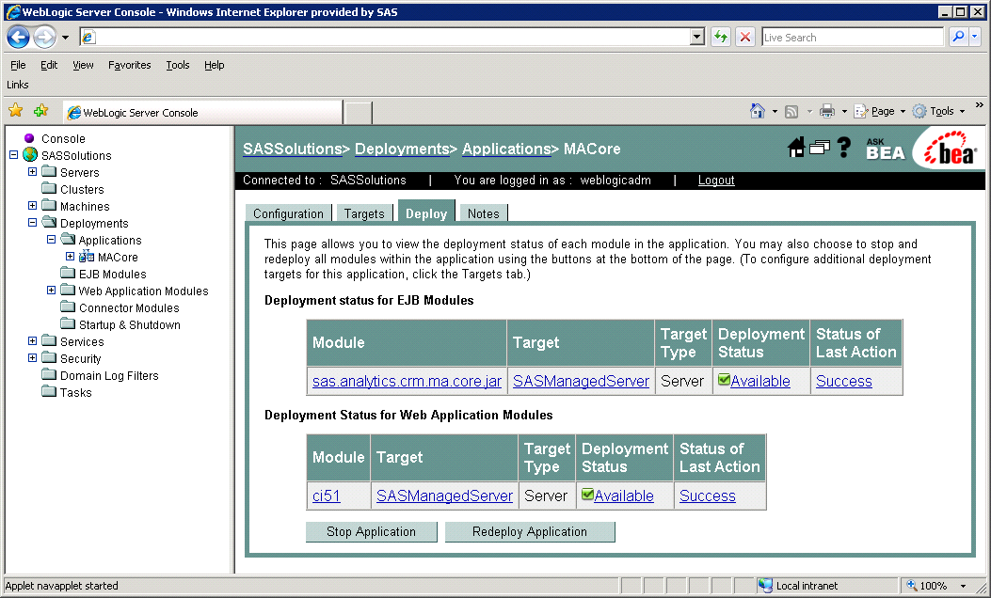

This will cause the jar file to be redeployed within the Weblogic server.

*Notes:*

1. *It is the* ***JAR*** *file that is being deployed not the* ***EAR*** *file. Once you run the Hot Fix setup program and extract the jar file, you're done with the ear.*
2. *To verify the path to the deployed jar file, click on the Configuration tab.*

**___ Weblogic Application Server Deployed**

This completes the application server deployment of the Hot Fix to Weblogic. Please now skip to section 3: Deployment Customer Intelligence Reporting War file.

**2.4.2: Deployment Instructions for IBM WebSphere.**

Deploying the Marketing Automation Application Server will involve uninstalling the current Marketing Automation Application, and reinstalling the ear file.

Before uninstalling the current Marketing Automation Application, make a back up copy of the current WAS.policy file. You can find the file in this directory.

**<was_home>/profiles/AppSrv01/config/cells/<machine name>/applications/Marketing Automation 5.1.ear/deployments/Marketing Automation 5.1/META-INF**

Where **<was_home>** is the ‘home’ directory location for WebSphere:

For example: **/saswork/IBM/WebSphere/AppServer**

Stop the **Marketing Automation 5.1** application from your Websphere console:

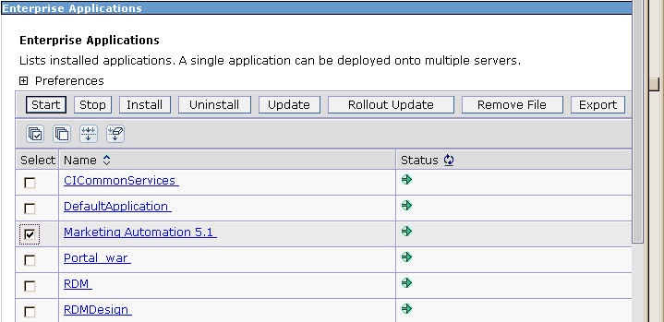

* Uninstall the **Marketing Automation 5.1** application from your Websphere console
* Save the configuration
* Next, the newly configured **Marketing Automation 5.1 application** needs to be reinstalled.
* The deployed location of the configured ear file is typically on the mid-tier machine that hosts the Marketing Automation Software. This machine should contain a directory or path named: ***<config-dir>/*Lev1/web/webapps**   
  Where **<config-dir>** is a directory name that represents the configuration directory used to originally configure the mid-tier environment through the SAS Software Navigator.

**Deploy Application to Web Server**

Deploy SAS Marketing Automation Application Server using the Websphere admin console

1. a) *Applications->Install New Application*
   1. • Select “Local path” radio button
   2. • Select Browse button and navigate to the MA ear file **(<config-dir>/Lev1/ web/webapps/sas.analytics.crm.ma.core.ear**)
   3. • Choose Next
   4. • Choose Next
   5. • Choose Continue on the Application Security Warnings panel
   6. • Step 1: Choose Next
   7. • Step 2: Choose Next
   8. • Step 3: Choose Next
   9. • Step 4: Choose Next
   10. • Step 5: Choose Next
   11. • Step 6: Check the “Select” box for Web Module “SAS Customer Intelligence Servlets” then Choose Next
   12. • Step 7: Choose Next
   13. • Step 8: Choose Finish
   14. • Save
2. b) *Applications->Enterprise Applications* 
   1. • Select Marketing Automation 5.1 link
   2. • Classloader Mode: PARENT_LAST
   3. • Apply/Save
3. c) Locate your saved copy of the WAS.policy file, and copy it back to its original location at

**<was_home>/config/cells/<machine name>/applications/Marketing Automation 4.4.ear/deployments/Marketing Automation 4.4/META-INF.**

1. d) *Applications->Enterprise Applications* 
   1. • Select Marketing Automation 5.1 check box
   2. • Select Start button

**___ Websphere Application Server Deployed**

**3. Deployment of the Customer Intelligence Reporting War file**

If you are deploying to **BEA WebLogic**, please now follow the instructions under section 3.1.1 Deployment Instructions for BEA WebLogic.

If you are deploying to **IBM WebSphere**, please now follow the instructions under section 3.1.2: Deployment Instructions for IBM WebSphere.

**3.1.1: Deployment Instructions for BEA WebLogic.**

* After logging into the Weblogic console, Navigate to Deployments==> Web Application Modules ==> sas.analytics.crm.ma.ccsservice in the left panel. (Note that your Target name may vary. The example below used the name SASManagedServer.)
* Click the Configuration tab to verify your deployment path is the Lev1/web/webapps/directory where the updated war file now resides.
* Click the Deploy tab in order to redeploy the war file.
* Click the 'ReDeploy' button under the Actions column.

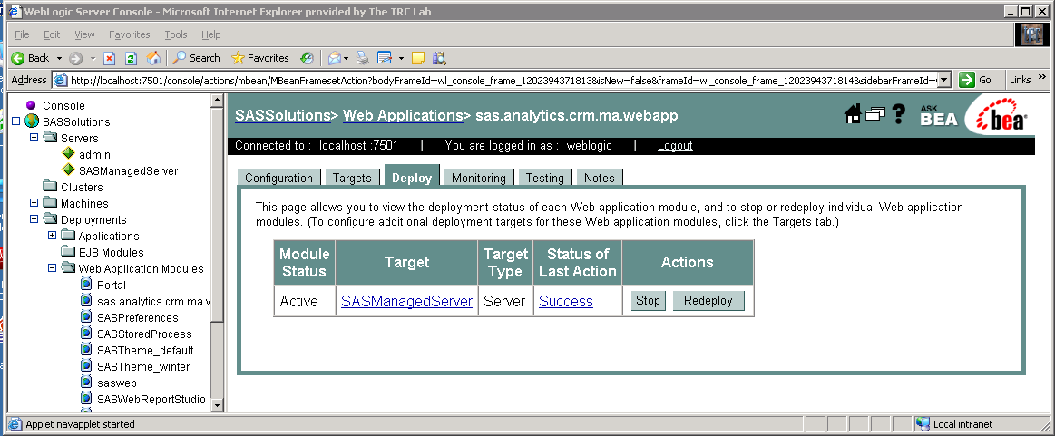

**___ Weblogic Customer Intelligence Reporting war Deployed**

This completes the Customer Intelligence reporting war file deployment to Weblogic. Please now skip to Section 4.

**3.1.2: Deployment Instructions for IBM WebSphere.**

Re-deploy SAS Customer Intelligence Reporting war components using the Websphere Admin console.

* Navigate to *Applications->Enterprise Applications*
* Select the *Stop* button to stop CICommonServices

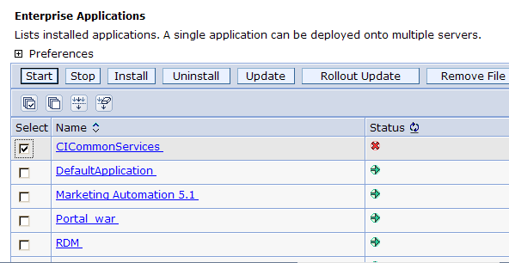

* Select the *update* button to update CICommonServices
* On the next screen, fill in the path to the sas_analytics_crm_ma_ccsservice_war file (Lev1/web/webapps)
* Type /ccs as the Context Root

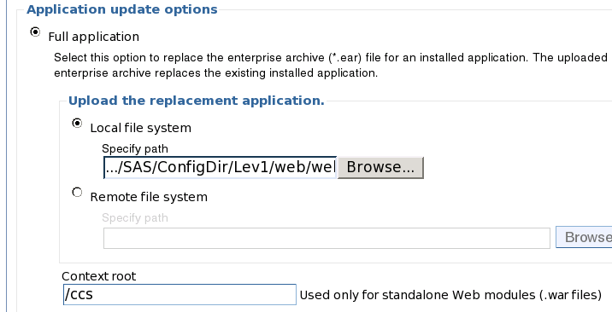

* Choose Next
* Choose Next
* Choose *Continue* on the Application Security Warnings panel
* Select *Step 4 Summary*
* Finish
* Save
* Navigate to Applications->Enterprise Applications
* Select *CICommonServices* link
* Change the Classloader Mode to *Parent_Last*
* Under the startup options section, enter *10* for the starting weight field.
* Apply and Save
* Navigate to Applications->Enterprise Applications
* Select *CICommonServices* check box
* Select *Start* button

**___ Websphere Customer Intelligence Reporting war Deployed**

**4. Changes required to the Customer Intelligence Reporting deployment**

If you have already installed the 51MA05 Hot Fix you should have already reconfigured the JMS messaging. If so skip this section and continue to section 5.

JMS messages enqueued on the CICommonCHTricklingInsertQueue or the

CICommonRHTricklingInsertQueue have reliable persistence. Changes were made as part of the MA5105 Hot Fix to make these transient. The deployment of the CI JMS messages needs to change due to this change in persistence.

If deployed to **BEA WebLogic**, please now follow the instructions under section 4.1.1 Changes for BEA WebLogic.

If deployed to **IBM WebSphere**, please now follow the instructions under section 4.1.2: Changes for IBM WebSphere.

**4.1.1: Changes for BEA Weblogic**

After logging into the Weblogic console, Navigate to Services==> JMS==> Servers ==> CICommonJMSServer in the left panel. (Note that your CICommonJMSServer name may vary. The example below uses the name CICommonJMSServer.)

Double click on CICommonJMSServer and change

Persistent Store: to None

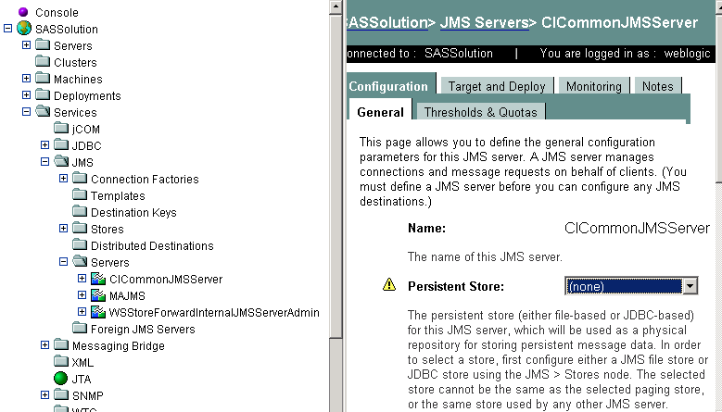

Then Navigate to Services==> JMS==> Stores ==> CICommonFileStore and right click and delete the CICommonFileStore

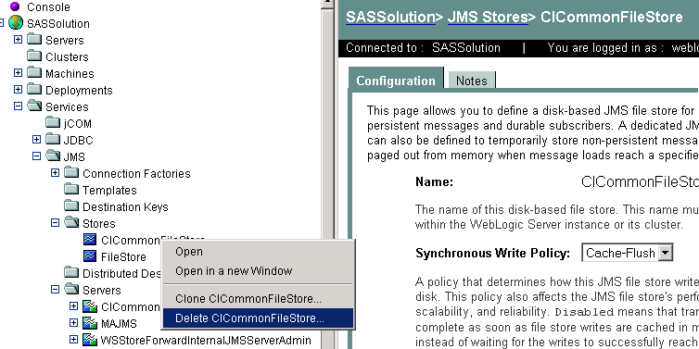

Then Navigate to Services==> JMS==> ConnectionFactories ==> CICommonQueueConnectionFactory and double click and Change Default Delivery Mode to NON-Persistent

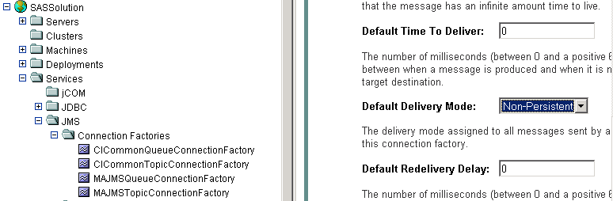

Then Navigate to Services==> JMS==> ConnectionFactories ==> CICommonTopicConnectionFactory and double click and Change Default Delivery Mode to NON-Persistent



Then Navigate to Services==> JMS==> Servers ==> CICommonJMS==>Destinations ==> All Destinations shown e.g. CICommonCHTricklingInsertQueue

Leave the Enable Store setting to default (which means it will use the JMS servers Store settings)

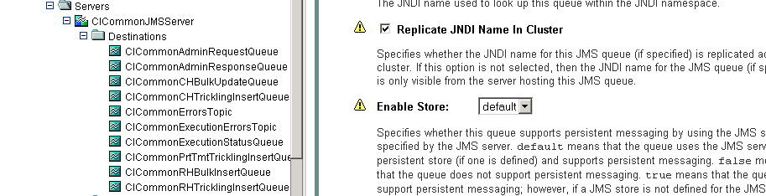

You have now completed all changes needed for CICommon on Weblogic

**___ Weblogic jms changes completed**

Please now skip to Section 5.

**4.1.2: Changes for IBM WebSphere**

After logging into the WebShere console, Navigate to Service Integration==> Buses==> CICOMMONBUS ==> Destinations on right of the screen. (Note that your bus name may vary. The example below uses the name CICOMMONBUS.) You will see a list of CICommon Queue’s and Topic’s of which the CICommonCHTricklingInsertQueue

CICommonRHTricklingInsertQueue

Need to be edited

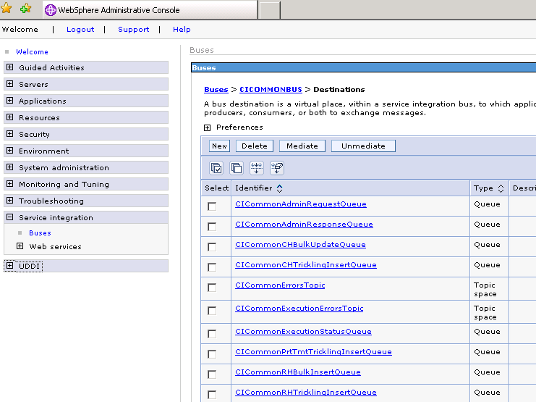

Double click on CICommonCHTrickingInsertQueue and

Under ***Quality of service*** section ensure

a. Enable Producers to over-ride default reliability - Should be checked

b. Default Reliability - Reliable Non Persistent

c. Maximum Reliability - Reliable Non Persistent

See example below:

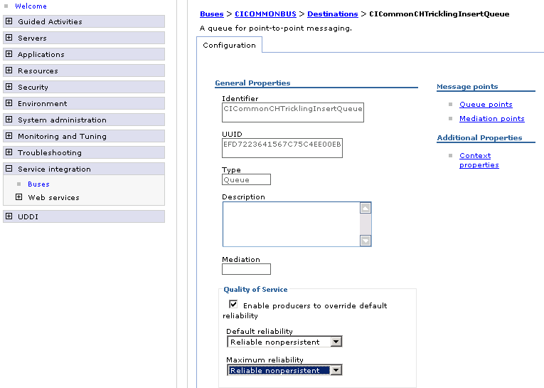

Click on Apply and then Save

Double click on CICommonRHTrickingInsertQueue and

Under ***Quality of service*** section ensure

a. Enable Producers to over-ride default reliability - Should be checked

b. Default Reliability - Reliable Non Persistent

c. Maximum Reliability - Reliable Non Persistent

See example below:

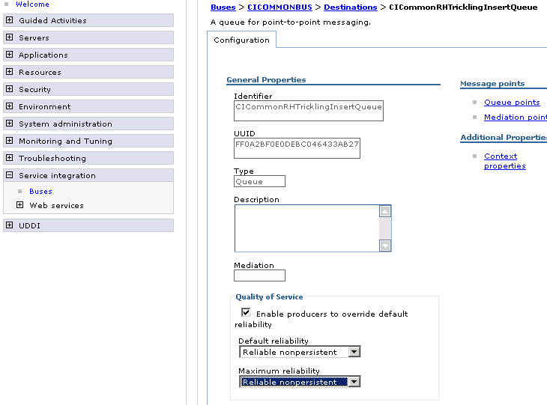

Click on Apply and then Save

You have now completed all changes needed for CICommon on websphere

**___ Websphere jms changes completed**

**5. Deployment of the SAS Marketing Automation Web Components Update**

This section is optional for Marketing Automation customers. If Campaign Web Studio is not installed, you can skip to section 6. Campaign Management customers (which are not Marketing Automation packages) do not have this component and therefore, must skip this step.

**5.1: Run the Post-configuration Ant script**

The 51MA13 Hot Fix has installed a post-configuration script, emawebnport_hf.xml that will repackage sas.analytics.ma.webapp.war with the updated code. You will find emawebnport_hf.xml in the sas installation directory: /SAS/SASMarketingAutomationWeb/4.1/Config Note this directory will contain a log called emawebnport_hf.log after the execution of this script.

Use a similar ant script and methodology discussed in section 2.2 above to deploy the changes:

**Example:**

ant -f "/SAS/SASMarketingAutomationWeb/4.1/Config/emawebnport_hf.xml"

-Dconfig.dir="/SAS/MAPlan" -Dtemp.dir="/SAS/temphf"

-Dinstall.loc="/SAS/SASMarketingAutomationWeb/4.1"

**5.2 Verify sas.analytics.crm.ma.webapp.war**

The ant script will copy an updated sas.analytics.crm.ma.webapp.war into the configuration directory at Lev1/web/webapps. The script will have created a copy of the original war file suffixed with today’s date.

The Marketing Automation Web Components web module needs to be redeployed in its respective application server (Weblogic or Websphere) for the changes to take effect.

**5.3: Deployment of the SAS Campaign Web Studio war**

If you are deploying to **BEA WebLogic**, please now follow the instructions under section 5.3.1: Deployment Instructions for BEA WebLogic.

If you are deploying to **IBM WebSphere**, please now follow the instructions under section 5.3.2: Deployment Instructions for IBM WebSphere.

**5.3.1: Deployment Instructions for BEA WebLogic.**

After logging into the Weblogic console, Navigate to Deployments==> Web Application Modules ==> sas.analytics.crm.ma.webapp in the left panel. (Note that your Target name may vary. The example below used the name SASManagedServer.) Click the Configuration tab to verify your deployment path is the Lev1/web/webapps/directory where the updated war file now resides.

Click the 'ReDeploy' button under the Actions column.



**___ Weblogic Campaign Web Studio Deployed**

This completes the application server deployment of the Hot Fix to Weblogic. Please now skip to section 6.

**5.3.2: Deployment Instructions for IBM WebSphere.**

Re-deploy SAS Marketing Automation Web components using the Websphere Admin console.

* Navigate to *Applications->Enterprise Applications*
* Select the *Stop* button to stop sas_analytics_crm_ma_webapp

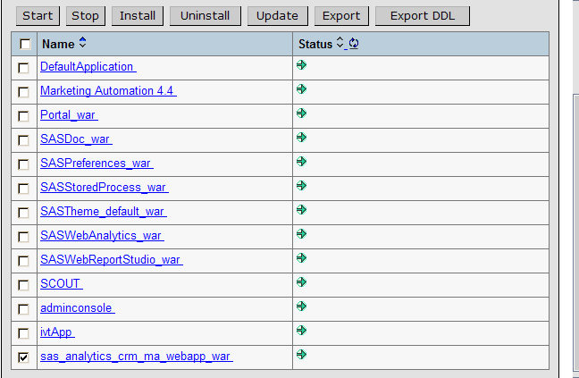

* Select the *update* button to update sas_analytics_crm_ma_webapp
* On the next screen, fill in the path to the sas_analytics_crm_ma_webapp_war file (Lev1/web/webapps)
* Type *ma* as the Context Root

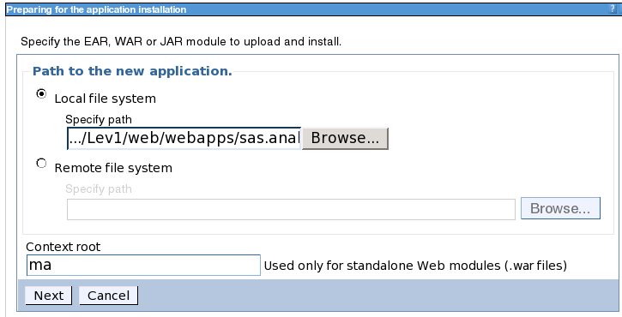

* Choose Next
* Choose Next
* Choose *Continue* on the Application Security Warnings panel
* Step 1 Select Next
* Step 2 Select Next
* Step 3 Check the box for Web Module “sas.analytics.crm.ma.webapp.war” then Select Next
* *Step 4 Summary,* SelectFinish
* Save

**___ Websphere Campaign Web Studio Deployed**

**6. Installing 51MA13 Hot Fix on the Server Tier**

The 51MA13 Hot Fix contains files for the Marketing Automation Server Tier.

The 51ma13_xxx directory under the directory containing the Hot Fix tar file will contain a file: mktautox6.tar (where x is the appropriate suffix for the Unix platform. A for AIX etc.)

*With the exception of HP Itanium, where the suffix will be ‘hx’, example below:*

*Ex: mktauto****hx****.tar*

Copy this file to the <SAS Install Dir>/SAS_9.1 then cd to that directory

Unarchive the file using tar –xvf mktautox6.tar. This will replace the necessary stored process and SAS macros with the Hot Fix versions

You can verify the updated files as follows

<SAS Install Dir>/SAS_9.1/cmacros/ma/sasmacr.sas7bcat new date of Jan xx 2010  
<SAS Install Dir>/SAS_9.1/sasstp/ma/ma_cdi_update_ch.sas new date of Jan xx 2010  
<SAS Install Dir>/SAS_9.1/sasstp/ma/ma_cdi_update_rh.sas new date of Jan xx 2010  
<SAS Install Dir>/SAS_9.1/misc/ma/mapublish.map new date of Jan xx 2010

<SAS Install Dir>/SAS_9.1/misc/ma/mapublish.map needs to be copied to the MAMisc folder. To know the location of this folder open the file <Config Dir>/Lev1/SASMain/appserver_autoexec.sas. Copy the mapublish.map to the path specified in the line : "libname MAMisc '..\MAMisc';" (default location: <Config Dir>/Lev1/SASMain/Data/MAMisc).

**___ SAS Compute Server updated**

**7. Common Data Model DDL and Alter Scripts**

**Released Version DDL and Alter Scripts**

SAS Customer Intelligence is delivered with Data Description Language (DDL) scripts to be used at installation time to create the SAS Customer Intelligence reporting Common Data Model on the underlying database. (<SAS Install Dir>/SAS_9.1/misc/ma/ciddlxxx.sas)

The scripts that accompany the 5.1 release of Customer Intelligence do not include any changes introduced by subsequent Hot Fixes. These updates have been provided through ‘alter’ DDL scripts that accompany the Hot Fixes.

New customer sites that have not configured the Common Data Model should refer to the product documentation on how to configure the common data model for the first time. Then create it before running any of the alter DDL scripts. The alter scripts must then be applied in sequence following successful creation and configuration of the Common Data Model tables.

If you already have Hot Fixes applied then please skip to the Hot Fix after the latest you have installed.

All DDL scripts are installed to <SAS Install Dir>/SAS_9.1/misc/ma

**51MA01 Hot Fix**

The Customer Intelligence Hot Fix (51MA01) introduced alter scripts to modify the key of the CI_RESPONSE_HISTORY table and to add a new column to the CI_CAMPAIGN table: CAMPAIGN_FOLDER_TXT. These scripts are designed to alter a Customer Intelligence 5.1 Common Data Model that has already been installed using the DDL that was shipped with the Customer Intelligence 5.1 release. The following files are provided by the service-pack in the <SAS Install Dir>/SAS_9.1/misc/ma location

|  |  |  |
| --- | --- | --- |
|  | File | Supported DB |
| 1 | cia01ora.sas | Oracle |
| 2 | cia01db2.sas | DB2 |
| 3 | cia01trd.sas | Teradata |
| 4 | cia01sqs.sas | SQL Server |
| 5 | cia01spd.sas | SPDS |

Appendix A: of this document provides specific guidance on how to apply the 51MA01 alter scripts.

**51MA02 Hot Fix**

The Customer Intelligence Hot Fix (51MA02) introduced a new DDL script for support of the Netezza database platform. The script comprised a full DDL that can be used to create the physical data structures for the Common Data Model tables on Netezza. The script included changes and updates that were introduced in 51MA01 so no additional alter script is required for Netezza. The file is named as follows:

|  |  |  |
| --- | --- | --- |
|  | File | Supported DB |
| 6 | ciddlntz.sas | Netezza |

If you have already installed the 51MA01 Hot Fix and are not using Netezza as your database then this script need not be run

**51MA05 Hot Fix**

The 51MA13 Hot Fix contains a second set of alter scripts one for each supported platform as well as introducing a new DDL script for support of the Neoview database platform and an update to the Netezza DDL.

The alter scripts provide updates to add five new budget columns to the CI_COMMUNICATION table.

Again, these scripts are designed to alter a Customer Intelligence 5.1 Common Data Model that has already been installed using the DDL that was shipped with the Customer Intelligence 5.1. These scripts should only be applied after the scripts from 51MA01 have been applied. The second set of alter script files are named as follows:

|  |  |  |
| --- | --- | --- |
|  | File | Supported DB |
| 1 | cia02ora.sas | Oracle |
| 2 | cia02db2.sas | DB2 |
| 3 | cia02trd.sas | Teradata |
| 4 | cia02sqs.sas | SQL Server |
| 5 | cia02spd.sas | SPDS |

The full Netezza DDL discussed under the 51MA02 Hot Fix has been superseded the new versions incorporates changes needed in 51MA13

A new DDL was added to support Neoview.

Customers who wish to use the Common Data Model with either Netezza or Neoview should refer to the product documentation on how to configure the common data model for the first time and apply these scripts accordingly. No alter scripts are provided for these two database platforms.

The Netezza and Neoview DDL scripts are named as follows:

|  |  |  |
| --- | --- | --- |
|  | File | Supported DB |
| 6 | ciddlntz.sas | Netezza |
| 7 | ciddlneo.sas | Neoview |

**Retrieved from "**[**http://sww.sas.com/saspedia/CI5.1_DDL_Scripts**](http://sww.sas.com/saspedia/CI5.1_DDL_Scripts)**"**

**Appendix A: Instructions for applying changes to the Common Data Model**

The 51MA13 Hot Fix has supplied Alter DDL scripts for the Customer Intelligence 5.1 Common Data Model. New customer sites that have not configured the Common Data Model should refer to the product documentation on how to configure the common data model for the first time before running the Alter DDL scripts.

The Hot Fix delivers Alter table DDL to modify the key of the CI_RESPONSE_HISTORY table and to add a new column to the CI_CAMPAIGN table: CAMPAIGN_FOLDER_TXT. These Alter Table DDLs will alter a Customer Intelligence 5.1 Common Data Model that has already been installed using the DDL that was shipped with the Customer Intelligence 5.1 product. The following files are downloaded with the Hot Fix.

**Oracle DDL:** cia01ora

**DB2 DDL:** cia01db2

**SQL Server DDL:** cia01sqs

**SPD Server DDL:** cia01spd

**Teradata DDL:** cia01trd

**PLEASE NOTE**: Prior to running any Alter table DDL, you must apply an update to the data in your CI_RESPONSE_HISTORY table(s). The primary key is being changed to add two columns: TREATMENT_SK and CELL_PACKAGE_SK. TREATMENT_SK was delivered in the original DDL script with a setting of “NULL”. TREATMENT_SK will now be set to “NOT NULL” to comply with the requirements of being a member of the primary key. All rows of data that contain a null value in the TREATMENT_SK column must be updated to a ‘NOT NULL” value (-1).

**Sample code to update TREATMENT_SK in the CI_RESPONSE_HISTORY table:**

PROC SQL;

UPDATE <YOUR CI_RESPONSE_HISTORY TABLE>

SET TREATMENT_SK = -1

WHERE TREATMENT_SK IS NULL;

QUIT;

**Overall code changes required before executing the DDL scripts:**

1. If the CI_RESPONSE_HISTORY table was renamed when initially created, to allow for multiple subjects or business contexts, rename the table specified in the alter table statements to match the table created by your install.
2. If the CONSTRAINT names were renamed when initially created to allow for multiple subjects or business contexts, rename the constraint names in the alter table statements to match the constraints created by your install.
3. Modify the SUBJECT_ID column in the list of primary key columns in the execute statement, to match the modifications that were made when the table was initially created. The SUBJECT_ID column was a placeholder column name in the original CI 5.1 CI_RESPONSE_HISTORY DDL and should have been modified with key columns to a customer specific subject.
4. If multiple CI_RESPONSE_HISTORY tables were created to accommodate multiple subjects and business contexts, copy and repeat all EXECUTE statements that contain the alter table code. Make the changes listed in 1, 2 and 3 above to each set of alter table code for each Response History table that you have uniquely created in your schema.  
     
   *** This completes the changes to CI_RESPONSE_HISTORY ***

**Install specifics for Teradata customers:**

Since the change to the CI_RESPONSE_HISTORY table requires a change to the primary key of the table, the above alter table instructions do not apply to Teradata. Teradata will not allow a primary key to be dropped and dropping the key is necessary to accomplish this modification to the table.

**Prior to running the supplied Teradata code, perform the following tasks:**

* If data exists in your CI_RESPONSE_HISTORY table, save the data to another table. This Hot Fix requires deletion of the CI_RESPONSE_HISTORY table, so saving the data is essential.
* Drop the existing CI_RESPONSE_HISTORY table.

**Make the following changes to the supplied code for the CI_RESPONSE_HISTORY table:**

1. If the CI_RESPONSE_HISTORY table was renamed when initially created to allow for multiple subjects or business contexts, rename the table specified in the create table statements to match the table created by your install.
2. If the primary key constraint name was renamed when initially created to allow for multiple subjects or business contexts, rename the constraint name in the create table code statements to match the constraints created by your install.
3. Modify the SUBJECT_ID column in the list of primary key columns in the execute statement, to match the modifications that were made when the table was initially created. The SUBJECT_ID column was a placeholder column name in the original CI 5.1 CI_RESPONSE_HISTORY DDL and should have been modified with key columns to a customer specific subject.
4. If multiple CI_RESPONSE_HISTORY tables were created to accommodate multiple subjects and business contexts, copy and repeat all EXECUTE statements that contain the create table code. Make the changes listed in 1, 2 and 3 above to each set of create table code for each Response History table that you have uniquely created in your schema.
5. Reload the saved data from your existing CI_RESPONSE_HISTORY table to the newly created CI_RESPONSE_HISTORY table.  
     
   *** This completes the changes to the CI_RESPONSE_HISTORY table. ***

**Install specifics for DB2 customers:**

The DB2 Alter table code has to be run in two passes. First make the changes listed above in the section titled: **Overall code changes required before executing the DDL scripts**. Next, after the primary key is dropped and the TREATMENT_SK column in the CI_RESPONSE_HISTORY table has been set to NULL in the first section of SQL code, you must have your DBA *REORG* the CI_RESPONSE_HISTORY table. This is a DB2 requirement and you cannot continue until this is done!

After your DBA has run the *REORG* on the CI_RESPONSE_HISTORY table, you must un-comment the final set of Proc SQL code statements provided in the last section of the DDL script and run only this SQL code to create the new primary key on the CI_RESPONSE_HISTORY table. This completes the changes to your DB2 CI_RESPONSE_HISTORY table.