|  |
| --- |
| SAS® Marketing Operations Management  SAS® MOM 6.4 W45003 |

SAS®

The correct bibliographic citation for this manual is as follows: SAS Institute Inc. 2016. *SAS:*  *Marketing Operations Management 6.4 W45003***.** Cary, NC: SAS Institute Inc.

**SAS®**  **Marketing Operations Management 6.4 W45003**

Copyright © 2016, SAS Institute Inc., Cary, NC, USA

All rights reserved. Produced in the United States of America.

**U.S. Government Restricted Rights Notice:** Use, duplication, or disclosure of this software and related documentation by the U.S. government is subject to the Agreement with SAS Institute and the restrictions set forth in FAR 52.227-19, Commercial Computer Software-Restricted Rights (June 1987).

SAS Institute Inc., SAS Campus Drive, Cary, North Carolina 27513.

July 2016

SAS® Publishing provides a complete selection of books and electronic products to help customers use SAS software to its fullest potential. For more information about our e-books, e-learning products, CDs, and hard-copy books, visit the SAS Publishing Web site at **support.sas.com/pubs** or call 1-800-727-3228.

SAS® and all other SAS Institute Inc. product or service names are registered trademarks or trademarks of SAS Institute Inc. in the USA and other countries. ® indicates USA registration.

Other brand and product names are registered trademarks or trademarks of their respective companies.

Contents

Preface 4

Purpose 4

Who Should Read This Document 4

Need for this Hot Fix 4

1 SAS® Marketing Operations Management 6.4 W45003 5

1.1 Pre-requisite 5

1.2 Install W45003 for 6.4 6

1.3 Post Installation Steps 8

2 Appendix 9

2.1 Issues Addressed 9

Preface

Purpose

This document has the instructions for applying W45003 on a SAS Marketing Operations Management 6.4 installation.

Who Should Read This Document

This document should be read by the person applying W45003.

Need for this Hot Fix

W45003 contains all the defect fixes prioritized by Technical Support that were reported by customers recently. Details later in this document.

# SAS® Marketing Operations Management 6.4 W45003



## Pre-requisite

***Note:***

* **SAS *Marketing Operations Management 6.4 should be installed before applying this hot fix.***

**(*The hot fix ID for 6.4_R1 hot fix 2 is W45003.)***

* ***To verify the MOM hot fix currently installed, navigate to the login page and click the “About” link at top right side of the screen. The hot fix version displayed correlates to the following:***
* ***6.4_R1 indicates that no hot fixes are currently applied***
* ***6.4_R1 Hotfix W45001 is the same as 6.4_R1 Hotfix 1***
* **If you use the manual mode of database script execution, then before applying the hot fix ensure you have run the script or scripts available at the following locations:**

***a.      For 6.4 (without any MOM 6.4 hot fixes applied) to 6.4 W45003, run the following scripts in the same order. The second script (if listed) should be executed only after the successful execution of the first script.***

1. ***Unzip “SAS MOM 6.4 W45003.zip” file to a folder and go to the Deployment folder inside the unzipped location.***
2. ***Unzip “64_R1_U0_HF0_To_64_R1_U0_HF1 Migration.zip” to get the Migration Schema Creation database script. Run the SQL code only on the tenant database before you select the manual execution mode.***
3. ***Unzip “64_R1_U0_HF1_To_64_R1_U0_HF2 Migration.zip” to a folder.***

* ***The Migration Schema Creation script (1- Migration Schema Creation.sql) should be executed on the tenant database.***
* ***The ODS script (1_ODS_DB_Migration_Create_Script.sql) should be executed on the ODS database after executing the Migration Schema Creation script on tenant database.***

***b.      For 6.4 (with MOM hot fix W45001 or W45002 already applied) to 6.4 W45003, run the following scripts in the same order. The second script (if listed) should be executed only after the successful execution of the first script.***

1. ***Unzip “SAS MOM 6.4 W45003.zip” file to a folder and go to the Deployment folder inside the unzipped location.***
2. ***Unzip “64_R1_U0_HF1_To_64_R1_U0_HF2 Migration.zip” to a folder.***

* ***The Migration Schema Creation script (1- Migration Schema Creation.sql) should be executed on the tenant database.***
* ***The ODS script (1_ODS_DB_Migration_Create_Script.sql) should be executed on the ODS database after executing the Migration Schema Creation script on tenant database.***

1. W45003 is released for SAS Marketing Operations Management 6.4. You should install this version on the servers.
2. If there is any customization, you are required to merge the custom code with the hot fix code base after applying this hot fix.
3. If there is any integration between SAS Marketing Operations Management solution and any other SAS Customer Intelligence solutions, refer to the appropriate deployment guides. (Please contact SAS Technical Support if you have questions about the deployment guides.)
4. The web services machine should be available and the IIS on this machine should be started. (This is used by the hot fix installer). Log on to the current SAS Marketing Operations Management setup through the browser to check.
5. The W45003 for SAS Marketing Operations Management 6.4 should be installed on all the servers in the setup in the following sequence:
   1. ***Application server***
   2. ***Solutions server***
   3. ***Cataloger server and Media server***
   4. ***All other servers***

## Install W45003 for 6.4

The following is updated by the hot fix installer:

* NTFS for all the tenants.
* Database for all the tenants created on the SAS Marketing Operations Management 6.4 installation.

Steps to Install W45003:

1. To install W45003, unzip ***SAS MOM 6.4 W45003.zip*** file to a folder.
2. Go to the ***Deployment*** folder inside the unzipped location.
3. Double click ‘Setup.exe’ and select the ‘Install HotFix’ option. **(Figure 1)**

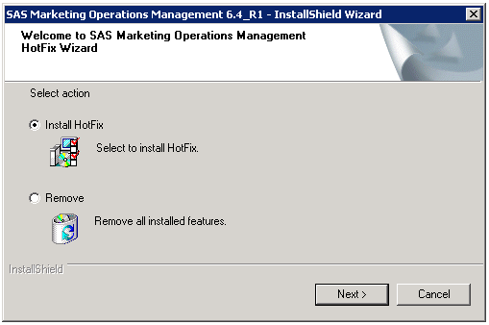

1. Select ‘Automatic’ for the database execution mode. If you wish to select Manual mode, ensure you have followed the pre-requisite steps in Section 1.1 of this document.

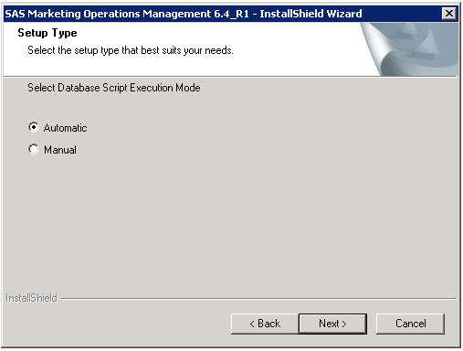

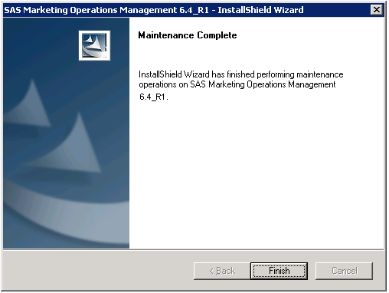

Figure No. 3

1. Be sure to restart the machine after installation.

## Post Installation Steps

1. If a new tenant is created after the installation of W45003, reset the IIS.
2. Restart all the Windows Services for SAS Marketing Operations Management after installation is complete.
3. Any custom code, if present, is replaced by the standard code after installation. Replace the standard code with the custom code created in the pre-requisite section.

# Appendix

## Issues Addressed

|  |  |  |
| --- | --- | --- |
| **Sr. No.** | **SAS Notes** | **Description** |
| **1.** | [SN-058435](http://support.sas.com/kb/58/435.html) | A digital asset channel might not be displayed correctly in SAS® Marketing Operations Management |
| **2.** | [SN-058437](http://support.sas.com/kb/58/437.html) | You cannot access a book type in the Artwork Producer module in SAS® Marketing Operations Management |
| **3.** | [SN-058438](http://support.sas.com/kb/58/438.html) | You receive an error when you modify a component facet in SAS® Marketing Operations Management |
| **4.** | [SN-058439](http://support.sas.com/kb/58/439.html) | The tabs for a plan's activity levels freeze in the Strategic Planner module in SAS® Marketing Operations Management |
| **5.** | [SN-058514](http://support.sas.com/kb/58/514.html) | Project status is not clearly communicated in the current descriptions for My Projects and Projects Calendar in SAS® Marketing Operations Management |
| **6.** | [SN-058447](http://support.sas.com/kb/58/447.html) | There is no error message when invalid input is entered by a user in an offer in SAS® Marketing Operations Management |
| **7.** | [SN-058510](http://support.sas.com/kb/58/510.html) | A performance problem exists in the ODS database in SAS® Marketing Operations Management |
| **8.** | [SN-058448](http://support.sas.com/kb/58/448.html) | The alert message is incorrect when a password does not qualify for the password policy in SAS® Marketing Operations Management |
| **9.** | [SN-058441](http://support.sas.com/kb/58/441.html) | You receive an error when you delete a cost category in the Strategic Planner module of SAS® Marketing Operations Management |
| **10.** | [SN-058449](http://support.sas.com/kb/58/449.html) | MOM Desktop does not install correctly in SAS® Marketing Operations Management |
| **11.** | [SN-058051](http://support.sas.com/kb/58/051.html) | An error occurs when you download consolidated files with the Media Annotations tool in SAS® Marketing Operations Management |
| **12.** | [SN-058216](http://support.sas.com/kb/58/216.html) | You receive an error for empty date fields when you initiate a campaign in SAS® Marketing Operations Management |
| **13.** | [SN-058450](http://support.sas.com/kb/58/450.html) | Static graphic tags are not listed after you upload an INDT file in SAS® Marketing Operations Management |
| **14.** | [SN-058512](http://support.sas.com/kb/58/512.html) | You cannot download a consolidated file in the Media Annotations tool in SAS® Marketing Operations Management |
| **15.** | [SN-058473](http://support.sas.com/kb/58/473.html) | SAS® Marketing Operations Management does not send custom response headers for dynamic webpage requests |
| **16.** | [SN-058460](http://support.sas.com/kb/58/460.html) | The thumbnail image for an asset in Digital Library has a black background in SAS® Marketing Operations Management |
| **17.** | [SN-058513](http://support.sas.com/kb/58/513.html) | Comments are duplicated for Microsoft Word and Microsoft Excel files in a route task in SAS® Marketing Operations Management |
| **18.** | [SN-058443](http://support.sas.com/kb/58/443.html) | The Activity Budget and Spends Report in SAS® Marketing Operations Management fails and returns an error |
| **19.** | [SN-058470](http://support.sas.com/kb/58/470.html) | The server returns an HTTP 200 response code when logon credentials are sent to the SAS® Marketing Operations Management website |
| **20.** | [SN-058511](http://support.sas.com/kb/58/511.html) | Asset counts do not show properly in SAS® Marketing Operations Management |
| **21.** | [SN-058531](http://support.sas.com/kb/58/531.html) | Fields are missing when you download an asset in the Digital Library module of SAS® Marketing Operations Management |
| **22.** | [SN-058524](http://support.sas.com/kb/58/524.html) | An "X" appears in the processing message after you upload an asset version in Digital Library in SAS® Marketing Operations Management |
| **23.** | [SN-058529](http://support.sas.com/kb/58/529.html) | You see an X instead of the list-view icon in the Marketing Workbench module of SAS® Marketing Operations Management |
| **24.** | [SN-058590](http://support.sas.com/kb/58/590.html) | You see an X instead of an asset's thumbnail image in the Digital Library module of SAS® Marketing Operations Management |
| **25.** | [SN-058598](http://support.sas.com/kb/58/598.html) | You receive an error after you select View Audit History in SAS® Marketing Operations Management |