|  |
| --- |
| SAS® Marketing Operations Management  SAS® MOM 6.4 W45001 |

SAS®

The correct bibliographic citation for this manual is as follows: SAS Institute Inc. 2015. *SAS:*  *Marketing Operations Management 6.4 W45001***.** Cary, NC: SAS Institute Inc.

**SAS®**  **Marketing Operations Management 6.4 W45001**

Copyright © 2015, SAS Institute Inc., Cary, NC, USA

All rights reserved. Produced in the United States of America.

**U.S. Government Restricted Rights Notice:** Use, duplication, or disclosure of this software and related documentation by the U.S. government is subject to the Agreement with SAS Institute and the restrictions set forth in FAR 52.227-19, Commercial Computer Software-Restricted Rights (June 1987).

SAS Institute Inc., SAS Campus Drive, Cary, North Carolina 27513.

November 2015

SAS® Publishing provides a complete selection of books and electronic products to help customers use SAS software to its fullest potential. For more information about our e-books, e-learning products, CDs, and hard-copy books, visit the SAS Publishing Web site at **support.sas.com/pubs** or call 1-800-727-3228.

SAS® and all other SAS Institute Inc. product or service names are registered trademarks or trademarks of SAS Institute Inc. in the USA and other countries. ® indicates USA registration.

Other brand and product names are registered trademarks or trademarks of their respective companies.

Contents

Preface 4

Purpose 4

Who Should Read This Document 4

Need for this Hotfix 4

1 SAS® Marketing Operations Management 6.4 W45001 5

1.1 Pre-requisite 5

1.2 Install W45001 for 6.4 6

1.3 Post Installation Steps 8

2 Appendix 9

2.1 Issues Addressed 9

Preface

Purpose

This document has the instructions for applying W45001 on a SAS Marketing Operations Management 6.4 installation.

Who Should Read This Document

This document should be read by the person applying W45001.

Need for this Hotfix

W45001 contains all the defect fixes prioritized by Technical Support that were reported by customers recently. Details later in this document.

# SAS® Marketing Operations Management 6.4 W45001



## Pre-requisite

***Note:***

* **SAS *Marketing Operations Management 6.4 should be installed before applying this hot fix.***

**(*The hot fix ID for 6.4_R1 Hotfix1 is W45001)***

* ***To verify the MOM hot fix currently installed, navigate to the login page and click the “about” link at top right side of the screen. The hot fix version displayed correlates to the following:***
* ***6.4_R1 indicates that no hot fixes are currently applied***
* **If you use the manual mode of database script execution, then before applying the hot fix, ensure you have run the script or scripts available, at the following locations:**

***a.      For 6.4 (without any MOM 6.4 hot fixes applied) to 6.4 W45001, run the following scripts in same order. The second script (if listed) should be executed only after the successful execution of first script.***

1. ***Unzip “SAS MOM 6.4 W45001.zip” file to a folder and go to the Deployment folder inside the unzipped location.***
2. ***Unzip “64_R1_U0_HF0_To_64_R1_U0_HF1 Migration.zip” to get the Migration Schema Creation database script. Run the SQL code only on the tenant database before you select the manual execution mode.***
3. W45001 is released for SAS Marketing Operations Management 6.4. You should install this version on the servers.
4. If there is any customization, you are required to merge the custom code with the hot fix code base after applying this hot fix.
5. If there is any integration between SAS Marketing Operations Management solution and any other SAS Customer Intelligence solutions, refer to the appropriate deployment guides available at <http://supportprod.unx.sas.com/software/ci/mrm_default.html> link.
6. The web services machine should be available and the IIS on this machine should be started. (This is used by the hot fix installer). Log on to the current SAS Marketing Operations Management setup through the browser to check.
7. The W45001 for SAS Marketing Operations Management 6.4 should be installed on all the servers in the setup in the following sequence:
   1. ***Application server***
   2. ***Solutions server***
   3. ***Cataloger server and Media server***
   4. ***All other servers***

## Install W45001 for 6.4

The following is updated by the hot fix installer:

* NTFS for all the tenants.
* Database for all the tenants created on the SAS Marketing Operations Management 6.4 installation.

Steps to Install W45001:

1. To install W45001, unzip ***SAS MOM 6.4 W45001.zip*** file to a folder.
2. Go to the ***Deployment*** folder inside the unzipped location.
3. Double click ‘Setup.exe’ and select the ‘Install Hotfix’ option **(Figure 1)**

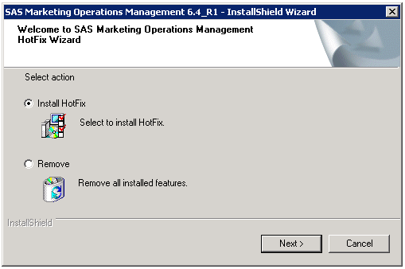

1. Select ‘Automatic’ for the database execution mode. If you wish to select Manual mode, ensure you have followed the pre-requisite steps in Section 1.1 of this document.

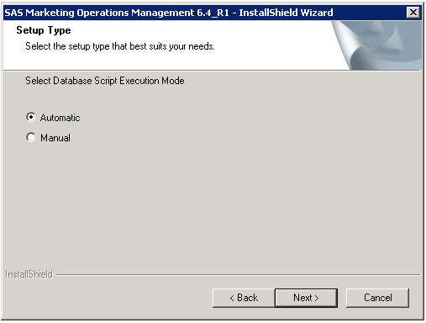

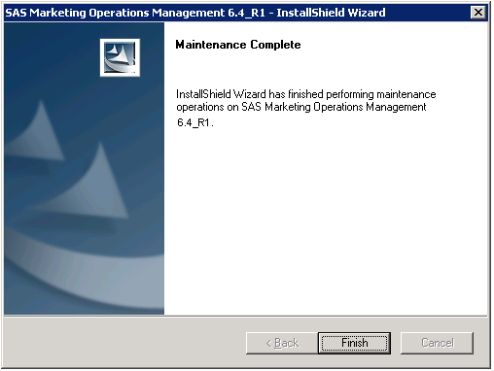

Figure No. 3

1. Be sure to restart the machine after installation.

## Post Installation Steps

1. If a new tenant is created after the installation of W45001, reset the IIS.
2. Restart all the Windows Services for SAS Marketing Operations Management after installation is complete.
3. Any custom code, if present, is replaced by the standard code after installation. Replace the standard code with the custom code created in the prerequisite section.

# Appendix

## Issues Addressed

|  |  |  |
| --- | --- | --- |
| **Sr. No.** | **SAS Notes** | **Description** |
| **1.** | [SN-055566](http://support.sas.com/kb/55/566.html) | The MOM Desktop application in SAS® Marketing Operations Management stops processing if a corrupt PDF file is found |
| **2.** | [SN-056795](http://support.sas.com/kb/56/795.html) | Thumbnails are not visible for Microsoft Office files in SAS® Marketing Operations Management |
| **3.** | [SN-056764](http://support.sas.com/kb/56/764.html) | An error occurs in the Leftbar Configuration tool when you modify a Digital Asset Finder application |
| **4.** | [SN-056861](http://support.sas.com/kb/56/861.html) | The search functionality is not collapsible in the Marketing Workbench or Approvals modules of SAS® Marketing Operations Management |
| **5.** | [SN-056877](http://support.sas.com/kb/56/877.html) | The forecast total is not bold in the Budgets tab for the Strategic Planner module of SAS® Marketing Operations Management |
| **6.** | [SN-056882](http://support.sas.com/kb/56/882.html) | An error is displayed in SAS® Marketing Operations Management when you select a navigation breadcrumb in the Strategic Planner module |
| **7.** | [SN-056770](http://support.sas.com/kb/56/770.html) | The German translation in a predefined calendar might be incorrect in SAS® Marketing Operations Management |
| **8.** | [SN-057063](http://support.sas.com/kb/57/063.html) | You cannot modify the contributor in a tracking task in SAS® Marketing Operations Management |
| **9.** | [SN-057027](http://support.sas.com/kb/57/027.html) | The date dependency field might not work in SAS® Marketing Operations Management |
| **10.** | [SN-056879](http://support.sas.com/kb/56/879.html) | The task contributor in the Marketing Workbench module of SAS® Marketing Operations Management is not assigned correctly |
| **11.** | [SN-056805](http://support.sas.com/kb/56/805.html) | The Cost Category Name filter does not work in a SAS® Marketing Operations Management ad-hoc report |
| **12.** | [SN-056783](http://support.sas.com/kb/56/783.html) | Activity dates are incorrect in the Gantt view of marketing calendars in SAS® Marketing Operations Management |
| **13.** | [SN-056825](http://support.sas.com/kb/56/825.html) | Route tasks in SAS® Marketing Operations Management are not initiated automatically and the task approver receives an error |
| **14.** | [SN-056836](http://support.sas.com/kb/56/836.html) | Facets might be missing from Gather Information tasks after you complete such tasks in in SAS® Marketing Operations Management |
| **15.** | [SN-056859](http://support.sas.com/kb/56/859.html) | Dashboard tabs do not change in SAS® Marketing Operations Management after you select a different tab |
| **16.** | [SN-057136](http://support.sas.com/kb/57/136.html) | You are logged on erroneously as a different user after you select a link in a forwarded email notification in SAS® Marketing Operations Management |