|  |
| --- |
| SAS® Marketing Operations Management  SAS MOM 6.3 R96004 |

SAS®

The correct bibliographic citation for this manual is as follows: SAS Institute Inc. 2015. *SAS:*  *Marketing Operations Management 6.3 R96004***.** Cary, NC: SAS Institute Inc.

**SAS®**  **Marketing Operations Management 6.3 R96004**

Copyright © 2015, SAS Institute Inc., Cary, NC, USA

All rights reserved. Produced in the United States of America.

**U.S. Government Restricted Rights Notice:** Use, duplication, or disclosure of this software and related documentation by the U.S. government is subject to the Agreement with SAS Institute and the restrictions set forth in FAR 52.227-19, Commercial Computer Software-Restricted Rights (June 1987).

SAS Institute Inc., SAS Campus Drive, Cary, North Carolina 27513.

May 2015

SAS® Publishing provides a complete selection of books and electronic products to help customers use SAS software to its fullest potential. For more information about our e-books, e-learning products, CDs, and hard-copy books, visit the SAS Publishing Web site at **support.sas.com/pubs** or call 1-800-727-3228.

SAS® and all other SAS Institute Inc. product or service names are registered trademarks or trademarks of SAS Institute Inc. in the USA and other countries. ® indicates USA registration.

Other brand and product names are registered trademarks or trademarks of their respective companies.

Contents

Preface 4

Purpose 4

Who Should Read This Document 4

Need for this Hotfix 4

1 SAS Marketing Operations Management 6.3 R96004 5

1.1 Pre-requisite 5

1.2 Install R96004 for 6.3 5

1.3 Post Installation Steps 7

2 Appendix 8

2.1 List of Fixes 8

Preface

Purpose

This document has the instructions for applying R96004 on SAS Marketing Operations Management 6.3 installation.

Who Should Read This Document

This document should be read by the person applying the R96004.

Need for this Hotfix

R96004 contains all the defect fixes prioritized by Technical Support that were reported by customers recently. Details later in this document.

# SAS Marketing Operations Management 6.3 R96004



## Pre-requisite

***Note:***

* **SAS *Marketing Operations Management 6.3 should be installed before applying this Hotfix.***
* ***To verify the MOM hot fix currently installed, navigate to the login page and click the “about” link at top right side of the screen. The hot fix version displayed correlates to the following:***
* ***6.3_R1 indicates that no hot fixes are currently applied***
* ***6.3_R1 Hotfix 1 indicates that R96002 is currently applied***
* ***6.3_R1 Hotfix 2 indicates that R96004 is currently applied***
* **If you use the manual mode of database script execution, then before applying the Hotfix ensure you have run the script or scripts available, at the following locations:**

***a.      For 6.3 (without any MOM 6.3 hot fixes applied or only R96001 is applied) to 6.3 R96004, run the following scripts in same order. The second script should be executed only after the successful execution of first script.***

***i.***[***http://support.sas.com/kb/54/453.html***](http://support.sas.com/kb/54/453.html)

***ii.***[***http://support.sas.com/kb/55/610.html***](http://support.sas.com/kb/55/610.html)

***b.      For 6.3 (with MOM hot fix R96002 or R96003 already applied) to 6.3 R96004 run the following script.***

***i.***[***http://support.sas.com/kb/55/610.html***](http://support.sas.com/kb/55/610.html)

1. R96004 is released for SAS Marketing Operations Management 6.3. You should install this version on the servers.
2. If there is any customization, you are required to merge the custom code with the Hotfix code base after applying this Hotfix.
3. If there is any integration between SAS Marketing Operations Management solution and any other SAS Customer Intelligence solutions, refer to the appropriate deployment guides available at <http://supportprod.unx.sas.com/software/ci/mrm_default.html> link.
4. The web services machine should be available and the IIS on this machine should be started. (This is used by the Hotfix installer). Log on to the current SAS Marketing Operations Management setup through the browser to check.
5. The R96004 for SAS Marketing Operations Management 6.3 should be installed on all the servers in the setup in the following sequence:
   1. ***Application server***
   2. ***Solutions server***
   3. ***Cataloger server and Media server***
   4. ***All other servers***

## Install R96004 for 6.3

The following is updated by the Hotfix installer:

* NTFS for all the tenants.
* Database for all the tenants created on the SAS Marketing Operations Management 6.3 installation.

Steps to Install the R96004:

1. To install R96004, unzip ***SAS MOM 6.3 R96004.zip*** file to a folder.
2. Go to the ***Deployment*** folder inside the unzipped location.
3. Double click ‘Setup.exe’ and select the ‘Install Hotfix’ option **(Figure 1)**

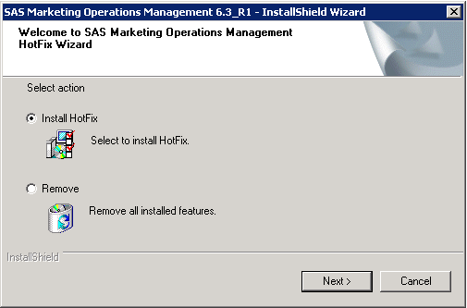

1. Select ‘Automatic’ for the database execution mode. If you wish to select Manual mode, ensure you have followed the pre-requisite steps in Section 1.1 of this document.

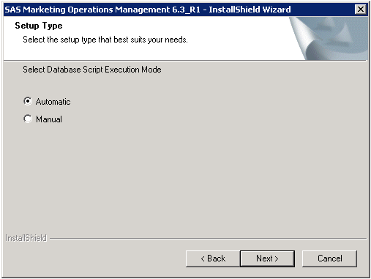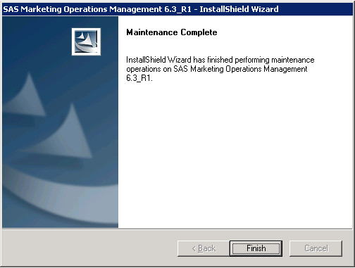

Figure No. 3

1. Be sure to restart the machine after installation.

## Post Installation Steps

1. If a new tenant is created after installation of R96004, reset the IIS.
2. Restart all the Windows Services for SAS Marketing Operations Management after installation is complete.
3. Any custom code if present is replaced by the standard code after installation. Replace the standard code with the custom code created in the prerequisite section

# Appendix

## List of Fixes

|  |  |  |  |  |
| --- | --- | --- | --- | --- |
| **Sr. No** | **Defect ID** | **Defect Description** | **Component** | **SAS Notes** |
| 1 | [S0928275](http://sww.sas.com/cgi-bin/quick_browse?defectid=S0928275) | Saving facet for more than 21 characters causes error in 6,3, works fine for 22-24 in U2 | SCHEMA DESIGNER | [SN-055439](http://support.sas.com/kb/55/439.html) |
| 2 | [S1025053](http://sww.sas.com/cgi-bin/quick_browse?defectid=S1025053) | RCA for MRKM-642 regarding asset count discrepancy | DAM | [SN-055565](http://support.sas.com/kb/55/565.html) |
| 3 | [S1063899](http://sww.sas.com/cgi-bin/quick_browse?defectid=S1063899) | Every time you login to MOM Desktop, it ask for Installing. | DAM | [SN-055564](http://support.sas.com/kb/55/564.html) |
| 4 | [S1131502](http://sww.sas.com/defects/java/iDefects/WebClient.html?defectid=S1131502) | NF: Enhancements in Calendars for sorting orders of Events, Holidays, and Calendar Items/Activities | MY CALENDARS | [SN-055549](http://support.sas.com/kb/55/549.html) |
| 5 | [S1162932](http://sww.sas.com/defects/java/iDefects/WebClient.html?defectid=S1162932) | Calendar information is not displayed when selected month has less data than previous month's data | MY CALENDARS |  |
| 6 | [S1162069](http://sww.sas.com/defects/java/iDefects/WebClient.html?defectid=S1162069) | Duplicate allocations are seen in exported PDF of My Tasks Resource Calendar | MY CALENDARS |  |
| 7 | [S1133023](http://sww.sas.com/defects/java/iDefects/WebClient.html?defectid=S1133023) | Marketing Activity Types calendar shows events at the top of the order in Gantt view | MY CALENDARS | [SN-055578](http://support.sas.com/kb/55/578.html) |
| 8 | [S1112431](http://sww.sas.com/cgi-bin/quick_browse?defectid=S1112431) | Install issue for batch upload desktop tool | DAM |  |
| 9 | [S1127171](http://sww.sas.com/cgi-bin/quick_browse?defectid=S1127171) | Release Money functionality | STRATEGIC PLANNER | [SN-055575](http://support.sas.com/kb/55/575.html) |
| 10 | [S1127581](http://sww.sas.com/cgi-bin/quick_browse?defectid=S1127581) | Low-Risk Security Finding: Error Messages in SAS MOM should be more Generic | MOM.GENERAL |  |
| 11 | [S1128888](http://sww.sas.com/cgi-bin/quick_browse?defectid=S1128888) | Error while downloading an asset in PIM | PIM | [SN-055573](http://support.sas.com/kb/55/573.html) |
| 12 | [S1129592](http://sww.sas.com/cgi-bin/quick_browse?defectid=S1129592) | Assets not cataloged to Deliverable if more than 15 facets are associated with Digital Asset | DAM | [SN-055576](http://support.sas.com/kb/55/576.html) |
| 13 | [S1132607](http://sww.sas.com/cgi-bin/quick_browse?defectid=S1132607) | An error occurs while release money from activity to program/ Plan level | STRATEGIC PLANNER | [SN-055561](http://support.sas.com/kb/55/561.html) |
| 14 | [S1132634](http://sww.sas.com/cgi-bin/quick_browse?defectid=S1132634) | Unable to export report to Excel | MOM REPORTS | [SN-054392](http://support.sas.com/kb/54/392.html) |
| 15 | [S1135115](http://sww.sas.com/cgi-bin/quick_browse?defectid=S1135115) | Optimizing Stored Procedure SP_RPT_ACTUALS_SUMMARY | MOM REPORTS |  |
| 16 | [S1138665](http://sww.sas.com/cgi-bin/quick_browse?defectid=S1138665) | I18N: Forwarding a task is not possible for a user whose default language is German | UI CONTROLS | [SN-055580](http://support.sas.com/kb/55/580.html) |
| 17 | [S1139053](http://sww.sas.com/cgi-bin/quick_browse?defectid=S1139053) | Web Service does not work on initial create offer form | UI CONTROLS | [SN-054891](http://support.sas.com/kb/54/891.html) |
| 18 | [S1141962](http://sww.sas.com/cgi-bin/quick_browse?defectid=S1141962) | WSS Settings not working on MOM6.4 release on punevmmomma/momma | MOM-MA INTEGRATION |  |
| 19 | [S1146135](http://sww.sas.com/cgi-bin/quick_browse?defectid=S1146135) | Dynamic SQL generated for the GetHierarchicalData call should get logged in case of exception | OBJECT MANAGER |  |
| 20 | [S1151666](http://sww.sas.com/cgi-bin/quick_browse?defectid=S1151666) | Forecast total calculation is incorrect on Budgets Tab for Plan and Activity. | STRATEGIC PLANNER | [SN-055558](http://support.sas.com/kb/55/558.html) |
| 21 | [S1152517](http://sww.sas.com/cgi-bin/quick_browse?defectid=S1152517) | Cross-Site Scripting issue reported for FileUpload for Binders in from control | UI CONTROLS |  |
| 22 | S1157708 | Blank upload files popup displayed while adding commitment | UI CONTROLS | [SN-055562](http://support.sas.com/kb/55/562.html) |
| 23 | [S1153853](http://sww.sas.com/cgi-bin/quick_browse?defectid=S1153853) | On user selection page, "All Groups" is displayed instead of selected group | INFRASTRUCTURE | [SN-055590](http://support.sas.com/kb/55/590.html) |
| 24 | [S1155101](http://sww.sas.com/cgi-bin/quick_browse?defectid=S1155101) | Optimize stored procedure SP_RPT_ACTIVITY_REPORTS | INFRASTRUCTURE | [SN-055579](http://support.sas.com/kb/55/579.html) |
| 25 | [S1162066](http://sww.sas.com/cgi-bin/quick_browse?defectid=S1162066) | OM INSTR logs does not contain stacktrace information | OBJECT MANAGER |  |
| 26 | S1133044 | Task ID is getting replicated across projects on concurrent access | MARKETING WORKBENCH | [SN-055584](http://support.sas.com/kb/55/584.html) |
| 27 | S1162475 | OM INSTR log file should be generated based on Month and Year in addition to ThreadID | OBJECT MANAGER |  |
| 28 | S1124448 | Dashboard Channels Disappearing- Issue with Dashboard Channel and personalization | DASHBOARD | [SN-055589](http://support.sas.com/kb/55/589.html) |
| 29 | S1157738 | Best Practice Tab is missing after selecting More Information in Calendar Activity | STRATEGIC PLANNER | [SN-055588](http://support.sas.com/kb/55/588.html) |
| 30 | [S1166851](http://sww.sas.com/cgi-bin/quick_browse?defectid=S1166851) | Comma in NH value is causing Error when uploading the TagTaxonomy Template | DAM |  |
| 31 | S1122377 | ICRP:Import plan not displaying the color theme of activity type in Calendar | MY CALENDARS |  |
| 32 | [S1136256](http://sww.sas.com/cgi-bin/quick_browse?defectid=S1136256) | SASMOM 6.3 HF1 installation failed on server with only Media Server installed | INSTALL AND DOCUMENTATION |  |
| 33 | [S1143627](http://sww.sas.com/cgi-bin/quick_browse?defectid=S1143627) | R96002 6.3 Hot Fix does not update Solutions and Media/Cataloger Servers in Multi Machine Environment | INSTALL AND DOCUMENTATION | [SN-054964](http://support.sas.com/kb/54/964.html) |
| 34 | [S1157615](http://sww.sas.com/cgi-bin/quick_browse?defectid=S1157615) | MOMDesktop does not respond when dropped a job of 400 files. | DAM | [SN-055495](http://support.sas.com/kb/55/495.html) |
| 35 | [S1160137](http://sww.sas.com/cgi-bin/quick_browse?defectid=S1160137) | I18N:"Value for the provided key does not exist." should be extracted | MOM.GENERAL |  |
| 36 | [S1123400](http://sww.sas.com/cgi-bin/quick_browse?defectid=S1123400) | Web Service on edit page of component facet throws error | UI CONTROLS | [SN-055550](http://support.sas.com/kb/55/550.html) |
| 37 | [S1149423](http://sww.sas.com/cgi-bin/quick_browse?defectid=S1149423) | Error in Marketing Workbench and\\or Marketing Operations Management | MOM-MA INTEGRATION |  |
| 38 | [S1158050](http://sww.sas.com/cgi-bin/quick_browse?defectid=S1158050) | User selection does not list all users in Plan universe | STRATEGIC PLANNER | [SN-055572](http://support.sas.com/kb/55/572.html) |
| 39 | S1124990 | ShowError.aspx parameters are not encrypted. | INFRASTRUCTURE |  |
| 40 | [S1171254](http://sww.sas.com/cgi-bin/quick_browse?defectid=S1171254) | Issue with value of radio button field on MOM Desktop. | DAM |  |
| 41 | S1173298 | 1 GB size job takes long time to get submitted on MOM Desktop. | DAM |  |
| 42 | S1173733 | I18N: On changing a contributor on task screen showing hours with changed value. | MARKETING WORKBENCH |  |