|  |
| --- |
| SAS® Marketing Operations Management  6.0 R 14 Update 2 M23010 |

SAS®

The correct bibliographic citation for this manual is as follows: SAS Institute Inc. 2016. *SAS:*  *Marketing Operations Management 6.0 R 14 Update 2 M23010***.** Cary, NC: SAS Institute Inc.

**SAS®**  **Marketing Operations Management 6.0 R 14 Update 2 M23010**

Copyright © 2016, SAS Institute Inc., Cary, NC, USA

All rights reserved. Produced in the United States of America.

**U.S. Government Restricted Rights Notice:** Use, duplication, or disclosure of this software and related documentation by the U.S. government is subject to the Agreement with SAS Institute and the restrictions set forth in FAR 52.227-19, Commercial Computer Software-Restricted Rights (June 1987).

SAS Institute Inc., SAS Campus Drive, Cary, North Carolina 27513.

December 2015

SAS® Publishing provides a complete selection of books and electronic products to help customers use SAS software to its fullest potential. For more information about our e-books, e-learning products, CDs, and hard-copy books, visit the SAS Publishing Web site at **support.sas.com/pubs** or call 1-800-727-3228.

SAS® and all other SAS Institute Inc. product or service names are registered trademarks or trademarks of SAS Institute Inc. in the USA and other countries. ® indicates USA registration.

Other brand and product names are registered trademarks or trademarks of their respective companies.

Contents

[Preface 4](#_Toc438650378)

[Purpose 4](#_Toc438650379)

[Who Should Read This Document 4](#_Toc438650380)

[Need for this Hotfix 4](#_Toc438650381)

[1 SAS Marketing Operations Management 6.0 R 14 Update 2 M23010 5](#_Toc438650382)

[1.1 Pre-requisites 5](#_Toc438650383)

[1.2 Install M23010 for 6.0 R14 Update 2 6](#_Toc438650384)

[1.3 Post Installation Steps 8](#_Toc438650385)

[1.4 Review SAS Notes 8](#_Toc438650386)

[2 Appendix 9](#_Toc438650387)

[2.1 Issues Addressed 9](#_Toc438650388)

Preface

Purpose

This document has the instructions for applying M23010 on SAS Marketing Operations Management 6.0 R 14 Update 2 installation.

Who Should Read This Document

This document should be read by the person applying the Hotfix.

Need for this Hotfix

This Hotfix contains all the defect fixes prioritized by Technical Support that were reported by customers recently. Details later in this document.

# SAS Marketing Operations Management 6.0 R 14 Update 2 M23010chapter_top

## Pre-requisites

***Note:***

* **SAS *Marketing Operations Management R14 Update 2 should be installed before applying this Hotfix.***

***(The hot fix ID for SAS MOM60\_R14\_Update2 Hotfix 4 is M23010)***

* ***Please check the Marketing Operations Management registry settings before installing this Hotfix.***

***(i.e. HKEY\_LOCAL\_MACHINE > SOFTWARE > Assetlink in the registry and check the value of “HotFix Number”)***

***If M23006 or higher hotfix is not installed and the “HotFix Number” registry key contains a value other than 0 then change the registry value to 0 and continue with the Hotfix installation, otherwise do not change the registry value and continue with the Hotfix installation.***

* ***The M23010 Installer automatically applies all previous R14 U2 hotfixes, if they are not already applied.***
* ***To verify the MOM hot fix currently installed, navigate to the login page and click the SAS logo at top right side of the screen. The hot fix version displayed correlates to the following:***
* ***SAS MOM60\_R14\_Release\_ DatedDDMMMMYYYY Update2 indicates that no hot fixes are currently applied***
* ***SAS MOM60\_R14\_Release\_ DatedDDMMMMYYYY Update2 Hotfix 1 indicates that M23006 is currently applied***
* ***SAS MOM60\_R14\_Release\_ DatedDDMMMMYYYY Update2 Hotfix 2 indicates that M23008 is currently applied***
* ***SAS MOM60\_R14\_Release\_ DatedDDMMMMYYYY Update2 Hotfix 3 indicates that M23009 is currently applied***
* ***If you use the manual mode of database script execution, then before applying the Hotfix ensure you have run the scripts available at the following locations in specified order:***
  1. ***For R14 U2 (without any MOM R14U2 hot fixes applied or M23005 and earlier hotfixes applied) to R14 U2 – M23010, run the following scripts in order. The third script is to be executed only after the successful execution of first two scripts.***
     1. [***http://support.sas.com/kb/53/782.html***](http://support.sas.com/kb/53/782.html)
     2. [***http://support.sas.com/kb/54/452.html***](http://support.sas.com/kb/54/452.html)
     3. [***http://support.sas.com/kb/55/614.html***](http://support.sas.com/kb/55/614.html)
  2. ***For R14 U2 (with MOM hotfix M23006 or M23007 already applied) to R14 U2 – M23010, run the following scripts in order. The second script should be executed only after the successful execution of first script.***
     1. [***http://support.sas.com/kb/54/452.html***](http://support.sas.com/kb/54/452.html)
     2. [***http://support.sas.com/kb/55/614.html***](http://support.sas.com/kb/55/614.html)
  3. ***For R14 U2 – M23008 to R14 U2 – M23010, run the following script.***
     1. [***http://support.sas.com/kb/55/614.html***](http://support.sas.com/kb/55/614.html)
  4. ***For R14 U2 – M23009 to R14 U2 – M23010, there are no database level changes and hence does not require any manual script execution.***

1. M23010 is released for SAS Marketing Operations Management 6.0 R 14 Update 2. Install this version on the servers.
2. If there is any customization, you are required to merge the custom code with the Hotfix code base after applying M23010.
3. If there is any integration between SAS Marketing Operations Management solution and any other SAS Customer Intelligence solutions, refer to the appropriate deployment guides accessible from the <http://supportprod.unx.sas.com/software/ci/mrm_default.html> link.
4. The web services machine should be available and the IIS on this machine should be started. (This machine is used by the Hotfix installer). Log on to the current SAS Marketing Operations Management setup through the browser to check.
5. M23010 for SAS Marketing Operations Management 6.0 R14 Update 2 needs to be installed on all the servers in the setup in the following sequence:
   1. ***Application server***
   2. ***Solutions server***
   3. ***Cataloger server and Media server***
   4. ***All other servers***

## Install M23010 for 6.0 R14 Update 2

The following is updated by the Hotfix installer:

* NTFS for all the tenants.
* Database for all the tenants created on the SAS Marketing Operations Management 6.0 R14 Update 2 installation.

Steps to Install M23010:

1. To install M23010, unzip ***SAS MOM 6.0R14-Update-02 M23010.zip*** file to a folder.
2. Go to the ***Deployment*** folder within the unzipped location.
3. Double click ‘Setup.exe’ and select the ‘Install Hotfix’ option **(Figure 1)**.

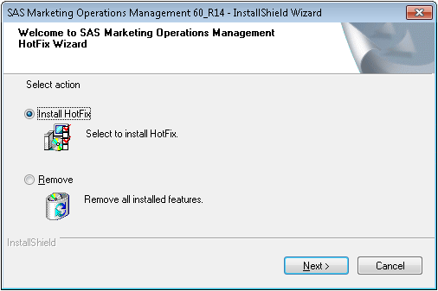

1. Select ‘Automatic’ for the Database Script Execution Mode. If you select Manual mode, make sure you have followed the pre-requisite steps in [Section 1.1](#_Pre-requisites) of this document.

For R14 U2 – M23009 to R14 U2 – M23010, there are no database level changes and hence Automatic and manual modes are same.

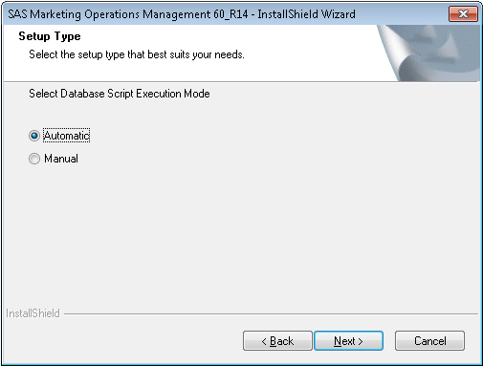

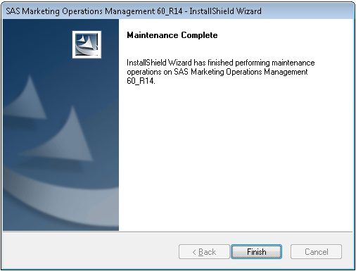

1. Be sure to restart the machine after installation.

## Post Installation Steps

1. If a new tenant is created after installation of M23010, reset the IIS.
2. Restart all the Windows Services for SAS Marketing Operations Management after installation is complete.
3. Any custom code if present is replaced by the standard code after installation. Replace the standard code with the custom code created in the prerequisite section.
4. Disable the HTTP protocol ­if you have selected the HTTPS protocol while installing SAS Marketing Operations Management. To disable the HTTP protocol follow the steps below:
5. Select Start > Run and enter **IIS Manager**.
6. Click the “Default Web Site” node in the tree view in the left pane.
7. Double-click the “SSL Settings” icon.
8. Select the “Require SSL” check box.
9. Select the “Ignore” radio button for the Client certificates.
10. Remove all references of crossdomain.xml from the web server and Media server machines.
    * 1. Search for crossdomain.xml on the web server and Media server machines.
      2. Delete the search results entries for crossdomain.xml.

## Review SAS Notes

After the installation of this hot fix and product post-installation instructions, please review the following SAS Notes for details on changes that are required to take advantage of the hot fixes. The SAS Notes below are organized by the hot fix they were introduced in. Knowing the last hot fix you installed will help you determine which sets of SAS Notes, below, need to be reviewed. For example, if your last hot fix was M23009, you need to review M23009 and above sets of SAS Notes.

**M23010**

**SAS Note 57168:** You receive errors when you add ODS support to an entity in SAS® Marketing Operations Management

<http://support.sas.com/kb/57/168.html>

# Appendix

## Issues Addressed

|  |  |  |
| --- | --- | --- |
| **Sr. No.** | **SAS Notes** | **Description** |
| **1.** | [SN-057164](http://support.sas.com/kb/57/164.html) | The related facet is missing when you create an ad hoc report for the target entity "Book Type" in SAS® Marketing Operations Management |
| **2.** | [SN-057168](http://support.sas.com/kb/57/168.html) | You receive errors when you add ODS support to an entity in SAS® Marketing Operations Management |
| **3.** | [SN-057163](http://support.sas.com/kb/57/163.html) | You receive an error when you delete a facet association in SAS® Marketing Operations Management |
| **4.** | [SN-056764](http://support.sas.com/kb/56/764.html) | An error occurs in the Leftbar Configuration tool when you modify a Digital Asset Finder application |
| **5.** | [SN-057136](http://support.sas.com/kb/57/136.html) | You are logged on erroneously as a different user after you select a link in a forwarded email notification in SAS® Marketing Operations Management |