Bulk Insert Using Postgres PSQL - PostgreSQL interactive terminal

NOTE: After successfully installing hot fix K6W002 for SAS Cost and Profitability Management 8.4, you must follow the instructions below to enable SAS Cost and Profitability Management operations to use the Postgres PSQL utility for bulk loading tables to the PostgreSQL database. Failure to do so will cause some operations, such as Generate Cubes, to fail.

- Post hot fix installation steps for the compute tier

- For Linux:

- Stop SAS Object Spawner and terminate any remaining abmx processes.
- Edit /<SAS configuration home>/Lev1/SASApp/ABMServer/config/settings.xml to add a line specifying the path to the PSQL utility, in the form <BulkPathPostgres>SpecifyPSQLPathHere</BulkPathPostgres>. For example:

Note:
The PSQL utility is deployed to the compute tier as part of the SASWebInfrastructurePlatformDataServer.

- Create a new configuration file named pgpass.conf in the path /<SAS configuration home>/Lev1/SASApp/ABMServer/config/. This file will store the PostgreSQL database passwords for the SAS Cost and Profitability Management database, as well as any PostgreSQL databases to which you may wish to export data using the PSQL bulk insert. Specify the passwords for different database users on separate lines, as below:
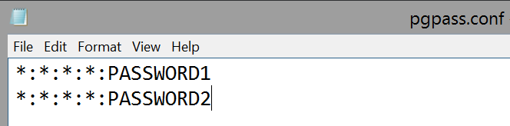

Note:
The SAS Cost and Profitability Management iomuser (chown iomuser) should be the owner of this file and must have R/W permission to it (chmod 0600).

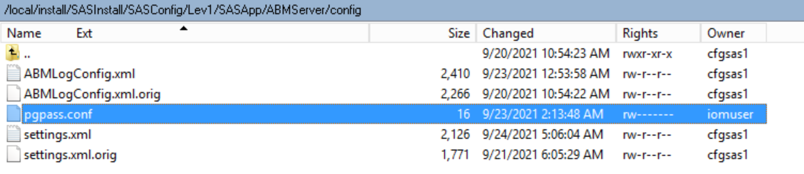

- Start SAS Object Spawner.

- For Windows:
The same instructions mentioned above should be followed.

- Stop SAS Object Spawner and terminate any remaining abmx processes.
- Edit \<SAS configuration home>\Lev1\SASApp\ABMServer\config\settings.xml to add a line specifying the path to the PSQL utility, in the form <BulkPathPostgres>SpecifyPSQLPathHere</BulkPathPostgres>
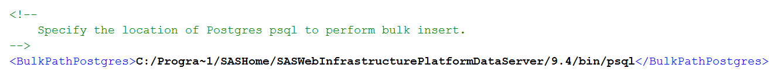
Note:
- The PSQL utility is deployed to the compute tier as part of the SASWebInfrastructurePlatformDataServer.
- If the PSQL path folders have space then please specify their short names.
For Ex: Progra~1 is the short name for Program Files.

- Create a new configuration file named pgpass.conf in the path \<SAS configuration home>\Lev1\SASApp\ABMServer\config. This file will store the PostgreSQL database passwords for the SAS Cost and Profitability Management database, as well as any PostgreSQL databases to which you may wish to export data using the PSQL bulk insert. Specify the passwords for different database users on separate lines, as below:

Note:
The SAS Cost and Profitability Management iomuser should be the owner of this file and must have R/W permission to it.

- Start SAS Object Spawner.

- PSQL bulk insert error logging
Any errors that occur when using the PSQL utility for bulk loading will be logged in the psqlbulk.log file, found in /<SAS configuration home>/Lev1/SASApp/ABMServer/temp/ (Linux) or \SASConfig\Lev1\SASApp\ABMServer\temp\ (Windows). If this file contains no error messages, the problem did not occur while running the PSQL bulk insert.

