|  |
| --- |
| SAS® Marketing Operations Management  MOM 6.0 R 14 Hotfix 2 |

SAS®

The correct bibliographic citation for this manual is as follows: SAS Institute Inc. 2013. *SAS® SolutionName: DocumentTitle***.** Cary, NC: SAS Institute Inc.

**SAS® SolutionName: DocumentTitle**

Copyright © 2013, SAS Institute Inc., Cary, NC, USA

All rights reserved. Produced in the United States of America.

**U.S. Government Restricted Rights Notice:** Use, duplication, or disclosure of this software and related documentation by the U.S. government is subject to the Agreement with SAS Institute and the restrictions set forth in FAR 52.227-19, Commercial Computer Software-Restricted Rights (June 1987).

SAS Institute Inc., SAS Campus Drive, Cary, North Carolina 27513.

January 2013

SAS® Publishing provides a complete selection of books and electronic products to help customers use SAS software to its fullest potential. For more information about our e-books, e-learning products, CDs, and hard-copy books, visit the SAS Publishing Web site at **support.sas.com/pubs** or call 1-800-727-3228.

SAS® and all other SAS Institute Inc. product or service names are registered trademarks or trademarks of SAS Institute Inc. in the USA and other countries. ® indicates USA registration.

Other brand and product names are registered trademarks or trademarks of their respective companies.

Contents

[Preface 4](#_Toc344361042)

[Purpose 4](#_Toc344361043)

[Who Should Read This Document 4](#_Toc344361044)

[1 MOM 6.0 R 14 Hotfix 2 5](#_Toc344361045)

[1.1 Pre-requisite 5](#_Toc344361046)

[1.2 Hotfix Content 5](#_Toc344361047)

[1.3 Deployment Hierarchy 5](#_Toc344361048)

[1.4 Database Scripts 6](#_Toc344361049)

[1.5 Applying the Fix 6](#_Toc344361050)

[2 Appendix 8](#_Toc344361051)

[2.1 List of Fixes 8](#_Toc344361052)

Preface

Purpose

This document has the instructions for applying Hotfix 2 on MOM 6.0 R 14 installation + 6.0 R14 Hotfix 1.

Who Should Read This Document

This document should be read by the person installing the Hotfix.

# chapter_topMOM 6.0 R 14 Hotfix 2

## Pre-requisite

The hotfix has been released for the MOM 6.0 R 14. This version is required to be installed on the servers. The MOM 6.0 R 14 Hotfix 1 to be applied on this installation.

***Note:* *Hotfix 1 should be applied before applying fixes from Hotfix 2 (follow MOM 6.0 R 14 Hotfix 1.docx).***

## Hotfix Content

The files for the hotfix are arranged in a hierarchy based on the components. There is a folder for each component – example, App Server, Web Server, Cataloger, etc.

There is a hierarchy under the components based on the deployment hierarchy. The files to be replaced on the target machine are in the respective locations.

***Note:*** *If there is any customization / configuration done for the customer, then the code / XML files will have to be merged and then updated for the respective tenant.*

## Deployment Hierarchy

The following folders are present for the Hotfix. Each folder has the files corresponding to the component.

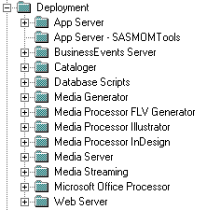

## Database Scripts

The database scripts are to be executed using SQL Server for each tenant. There is a ‘Database Scripts’ folder, which has the SQL Server script – ‘R14\_Hotfix2\_Script.sql’.

## Applying the Fix

* ***Hotfix 1 should be applied before applying fixes from Hotfix 2 (follow MOM 6.0 R 14 Hotfix 1.docx).***
* Copying the files:

Download the Hotfix 2 folder on a server.

On each of the component servers, copy the folder from the Hotfix 2 hierarchy.

Replace the files in the installation directory from the corresponding component folder in the hotfix.

The files present under the Client Template folder, are to be replaced in the client template hierarchy, and also for each tenant.

In SQL server execute the database script provided in the ‘Database Scripts’ folder in the hotfix for each tenant database.

***Note***:

* Stop SAS MOM Services and IIS before replacing the files.
* Copy the contents of “App Server - SASMOMTools” folder into “SASMOMTools” folder present on “App Server” machine.
* On “App Server” machine : Register “DocumentFormat.OpenXml.dll” in GAC

1. Run command “assembly” ( To open the run popup press “Windows + R”)

*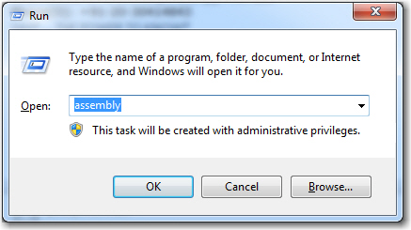*

1. Drag and Drop “DocumentFormat.OpenXml.dll” present in “SASMOMTools” folder in the assembly

*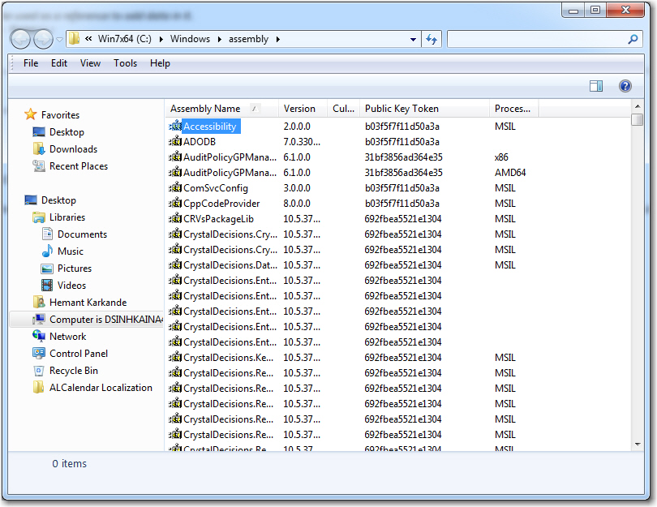*

* Delete "DocumentFormat.OpenXml.dll" file (if present) from "<Installation Dir>\ALServices\bin\" folder on “App Server” machine.
* Start SAS MOM Services and IIS on all machines once all files are copied and above steps are completed.

# Appendix

## List of Fixes

|  |  |  |  |
| --- | --- | --- | --- |
| **No.** | **Defect ID** | **Defect Description** | **Component** |
| 1 | S0851801 | CRP:Adhoc Report\_Export to excel not working | MOM REPORTS |
| 2 | S0869895 | CRP:Adhoc Report\_Export To Excel\_Time out error | MOM REPORTS |
| 3 | S0913229 | CRP PERFORMANCE:MOM Adhoc report generation consumes all CPU on AppSvr w/ 2 reports running + logon severely impact | MOM REPORTS |
| 4 | S0880460 | PERFORMANCE:Eliminate remaining non parameterized queries | INFRASTRUCTURE |
| 5 | S0887104 | Error while opening calendar if currency is added as a filter | OBJECT MANAGER |
| 6 | S0887193 | Offer Calendar does not show any data if personalized offer type contains special chars | MY CALENDARS |
| 7 | S0888281 | Delimiter issue in Adhoc report. | MOM REPORTS |
| 8 | S0891445 | OM - IN Operator not working as Excepted | INFRASTRUCTURE |
| 9 | S0894483 | CRP:Issue with export to excel of Adhoc Report for Multi Select fields | MOM REPORTS |
| 10 | S0895857 | CET:Files from XML MountPoint gets deleted even if the entity record deletion is rolled back from DB | MARKETING WORKBENCH |
| 11 | S0898596 | CRP:Activity nomenclature set at level3 set as tactics, on activity type selection incorrect message | STRATEGIC PLANNER |
| 12 | S0901388 | CRP:Download Digital Asset' actions from microsites are not captured in the digitalAsset table | DAM |
| 13 | S0905288 | Task Status for Route type remains as Submission In Progress for Video Files | MARKETING WORKBENCH |
| 14 | S0907749 | CRP:Download doesn't work after accepting terms & conditions | DAM |
| 15 | S0909829 | CRP:Issues with scheduled Adhoc report | MOM REPORTS |
| 16 | S0909845 | CRP:Scheduled Adhoc report didn't deliver | MOM REPORTS |
| 17 | S0865931 | CRP:Issue with Adhoc report scheduling | MOM REPORTS |
| 18 | S0911106 | BHUP:Error while adding attributes to facets into R14 - State Farm | SCHEMA DESIGNER |
| 19 | S0919414 | CRP:Timesheet issue for Bose | TIMESHEETS |
| 20 | S0915853 | Issue while opening a time sheet link from Approvers end | TIMESHEETS |
| 21 | S0919418 | Timesheet For Approvals> shows 3 records for a 'Timesheet Date' (11/01/1950) | TIMESHEETS |
| 22 | S0924708 | Resource category forecast configuration file error comes while creating plan | STRATEGIC PLANNER |
| 23 | S0922920 | Select Resource Type for 3 level hierarchy fails for an Assignment Task | MARKETING WORKBENCH |
| 24 | S0915768 | Caching of metadata tables do not work | OBJECT MANAGER |
| 25 | S0914846 | CRP:Inconsistency in Stored Procedure execution timing | INFRASTRUCTURE |
| 26 | S0916418 | Not able to delete invoice from commitment page | STRATEGIC PLANNER |
| 27 | S0926960 | Commitment Approvals->View consolidated file throws error | STRATEGIC PLANNER |
| 28 | S0928270 | NSPC:PDF consolidation taking place even after consolidated file is available in Commitment Approvals | STRATEGIC PLANNER |
| 29 | S0928978 | CRP:Task is not showing the latest file | MARKETING WORKBENCH |
| 30 | S0930264 | Error while open exported excel if boolean field is added in display coulums in adhoc report | MOM REPORTS |
| 31 | S0930269 | Export to excel gives error message for a specific report having float field | MOM REPORTS |
| 32 | S0930293 | Project priority value is not shown properly in project list | MARKETING WORKBENCH |
| 33 | S0898528 | Exception Occurs: Deleting resources in Vendor management resources Tab | VENDOR  MANAGEMENT |
| 34 | S0884925 | Title\_Shared shown as header in resources tab of vendor | VENDOR  MANAGEMENT |
| 35 | S0929529 | Error on opening scheduler for adhoc report | MOM REPORTS |
| 36 | S0930436 | Error observed for Object Manager under tenant logs on R14HF2 Setup | OBJECT MANAGER |
| 37 | S0930002 | Adhoc report pending schedules not handled if reportscheduler service is offline. | MOM REPORTS |
| 38 | S0930554 | Response attachments are not seen to the initiator of PCI Approval task | MARKETING  WORKBENCH |