Import Information Maps
- Start SAS Management Console 9.2 on the machine where it is installed and login using a suitable metadata profile.
- Click on the Folders tab
- Navigate Products SAS Fraud Management Operational Reports Data Sources
- Right click on Data Sources and select Import SAS Package
- Selection shown below

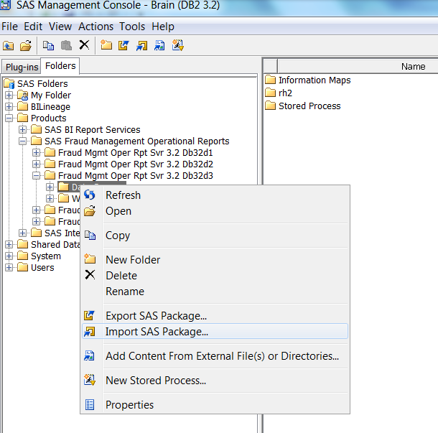

- In the Import prompt select Browse and navigate to $SAS_ROOT/misc/fraudoprpt/config/Deployment/Packages where the updated XAMS information maps package (fraudoprcfg_InfoMaps_XAMS.spk) is stored.
- Select “fraudoprcfg_InfoMaps_XAMS.spk” and click OK
- Select Next
- You should see the xams_inf_frq_rule_firing information map:
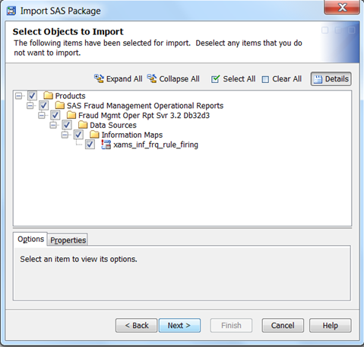

- Select Next
- You will see an “About Metadata Connections” prompt – select Next.
- Select the application server – if populated then select Next.
- Select libraries – if populated then select Next.
- Select tables – if populated then select Next.
- You will see a “Summary” prompt – ensure selections are correct and then select Next.
- Importing Objects dialog shows import progress which turns to:
- Import Complete with “process completed successfully” message.
- Select Finish.

