Instructions to import Information Map for Overall False Positive Report

- Copy Overall_False_Positive.spk from the hotfix install directory to a directory on a Windows or UNIX machine
- Login to SMC as the administrator
- Click on Folders tab
- Navigate to the folder where Information Maps were earlier imported
- Right-click on the folder and select Import SAS Package from the menu
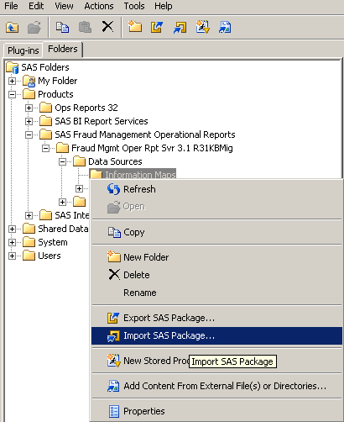

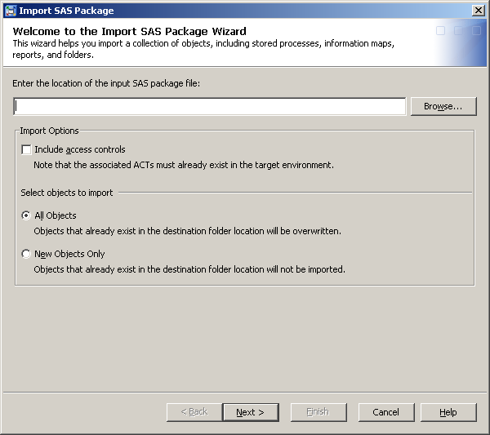
- Browse to the location where Overall_False_Positive.spk was copied to in Step 1 and click Next

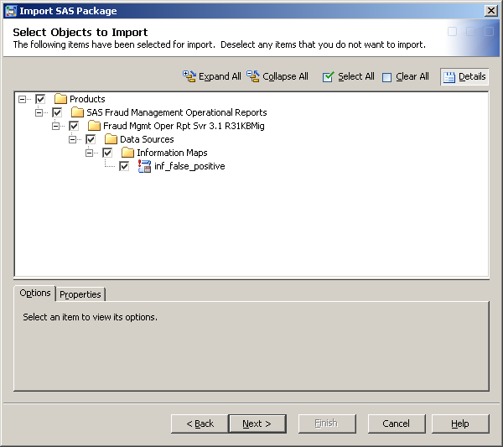
- The boxes should have check marks against them. Click Next.

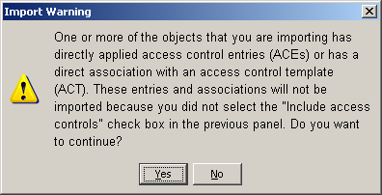
- Click Yes

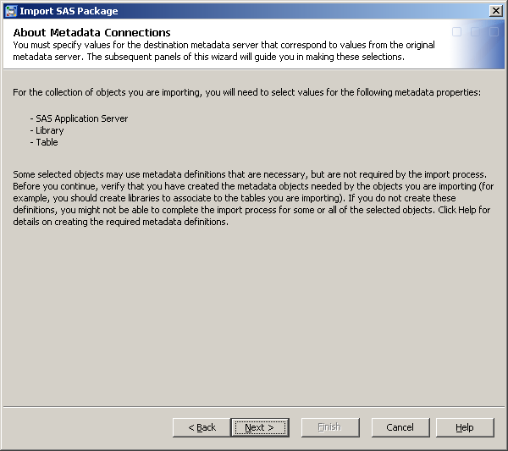
- Click Next

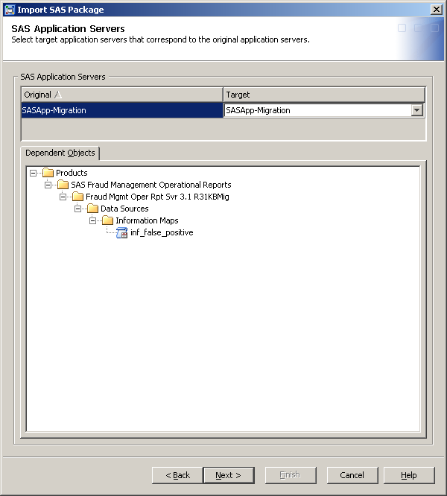
- Make appropriate selections for SAS Application Server and Library from the Target drop down. The Target values must correspond to your environment. Click Next on the screens.

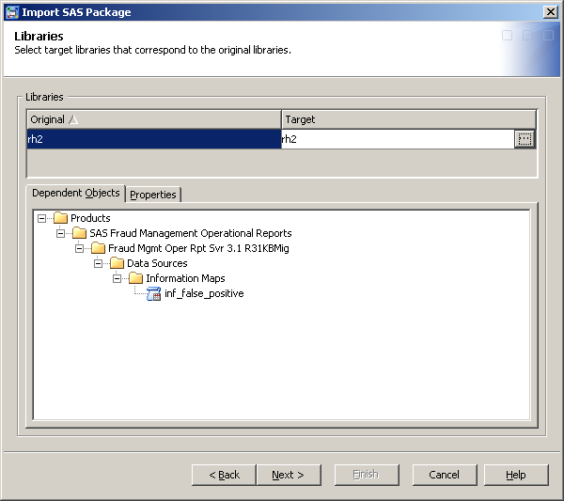

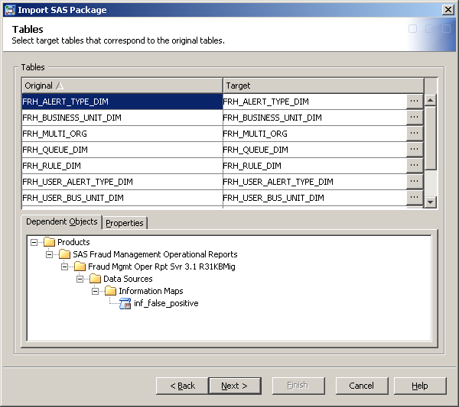

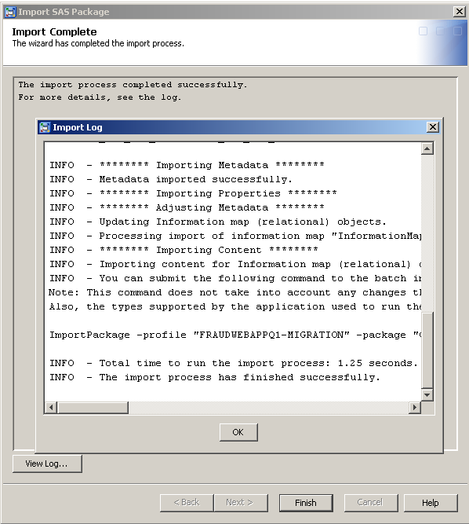
- Check the log to validate that the import completed successfully. Click OK.

- Click on the import folder and check on the right panel that the Last Modified timestamp corresponds to the time of import. This ensures that the existing Information Map for the report was replaced with the one in the hotfix.

