User Variable Values Report Usage Guide

- Login to WRS, navigate to the location for the User Variable Values Report and click on the report name. The report filter page displays as below:
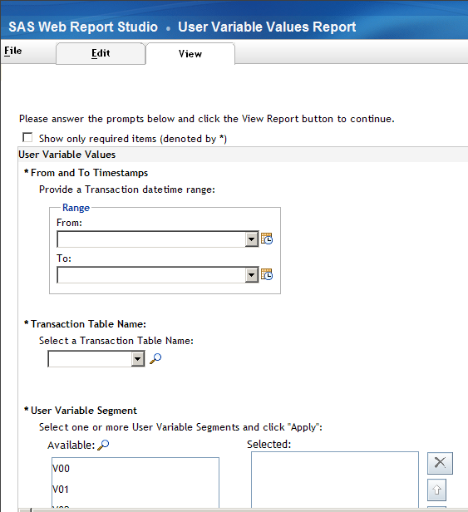

- Provide From and To Timestamps to retrieve transactions for which User Variable values will be displayed. You may click on the Calendar icons to the right of the drop downs to provide specific timestamp values or select one of the pre-defined values in the drop downs.
NOTE: The maximum value allowed in the “To” timestamp is configurable and, by default, set to 1 hour from the current date and time. Entering a To timestamp later than the maximum value allowed will result in a message such as the below:

To change the maximum value allowed in the To timestamp, please talk to your administrator.

- On the next filter, select a transaction table name from the drop down list. An example below:

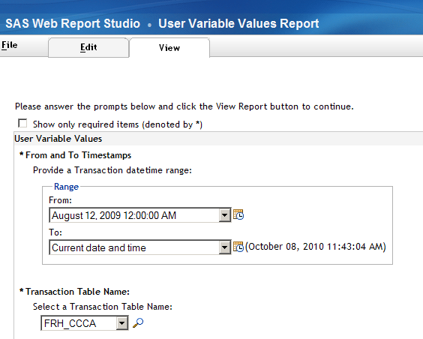

- Next, make User Variable Segment selections. Multiple selections are allowed. To make a selection, double-click on a value in the Available List box or highlight a value and use the single arrow. Repeat the process for other values. To select all values, simply click the double arrow. Once, selections have been made, click the Apply button. The example below shows selections made for the V00 and V01 segments.
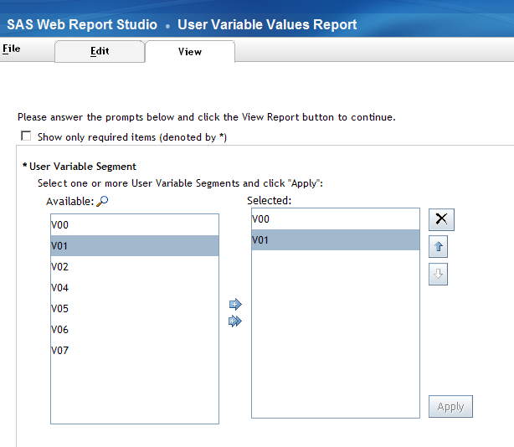

- The User Variable Business Name filter will be populated with available user variables corresponding to the segment selections made in the prior step. This is an optional filter – you may or may not make any variable selections. If no selections are made, values for all the variables corresponding to the selected segments will be extracted from the transactions. If variable selections are made, values will be extracted inly for the selected variables. You may choose not to make any variable selections for one segment and one or more variable selections for another segment. In the example below, one variable each is selected from the V00 and V01 segments.

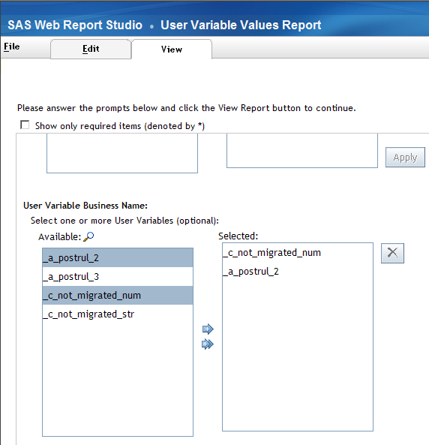

- Having completed all filter selections, click View Report.

- If the estimated number of transactions to be displayed exceeds the configured limit, a message such as the one below will be displayed. You would then have to revise your selections to fetch less number of transactions. Click on Data – Refresh to go back to the filter screen. You may specify a narrower datetime range or select fewer segments or a combination of both.

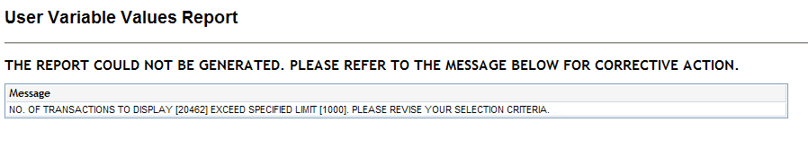

- Having revised the filter selections, click View Report. If the transaction limit is not exceeded, you would see a report such as the one below.

The report displays the required selection criteria (not optional criteria) for the report. The data is sorted by TRANSACTION ID. Each row displays user variables and their values for a segment.

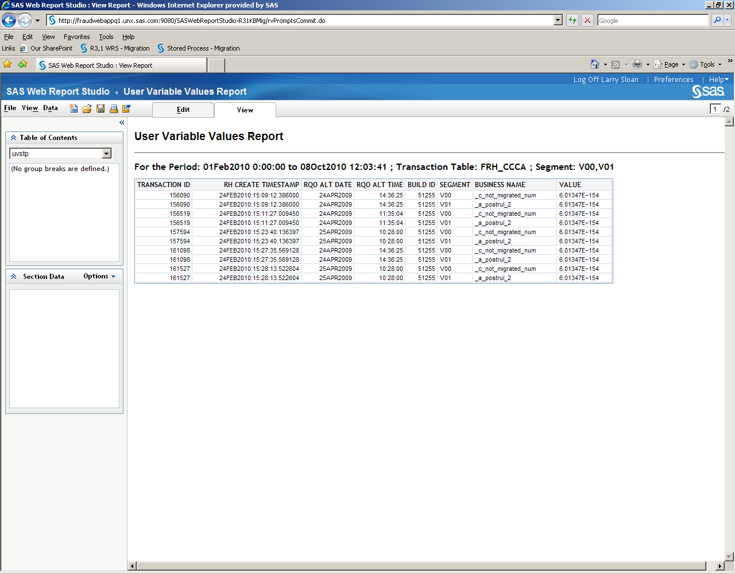

- The report may be exported to Excel by clicking on File -> Export.

