Package Import Instructions for User Variable Values Report

- The user_variable_report.spk package consists of:
  - A Stored Process with logical name, User Variable Values, and physical name, stp_user_variable.sas
  - A report file, User Variable Values report.srx
  - Associated metadata
- Copy user_variable_report.spk from the hotfix install directory to a directory on a Windows or UNIX machine
- Login to SMC as the administrator
- Click on Folders tab
- Navigate to the “Fraud Mgmt…” folder for your implementation
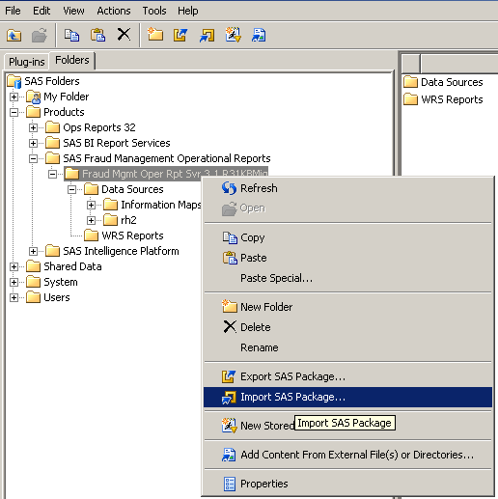
- Right-click on the folder and select Import SAS Package from the menu

- Browse to the location where user_variable_report.spk was copied to in Step 2 and click Next.
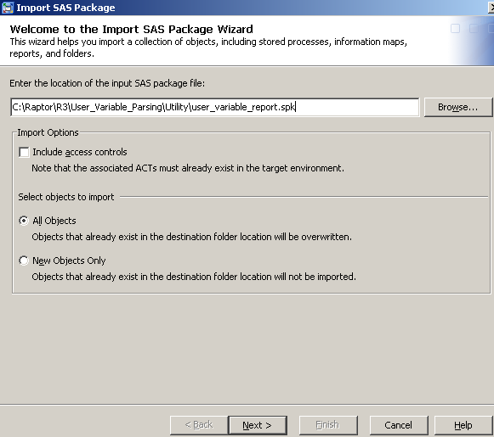

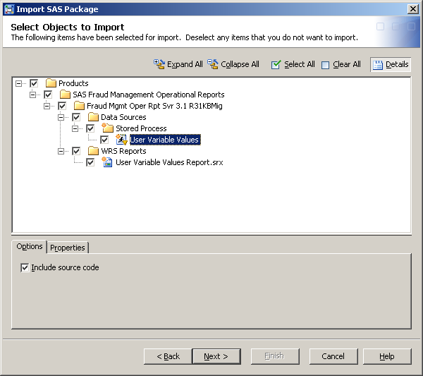
- The boxes should have check marks against them. Click on User Variable Values and verify that "Include source code” is checked. Click Next.

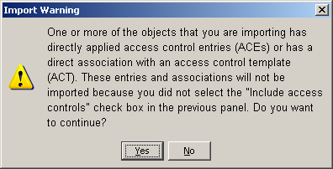
- Click Yes

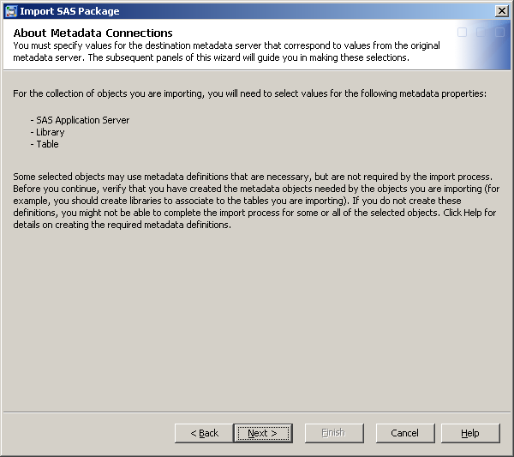
- Click Next

- Select the SAS Application Server for your environment from available values in the Target drop down. Click Next.
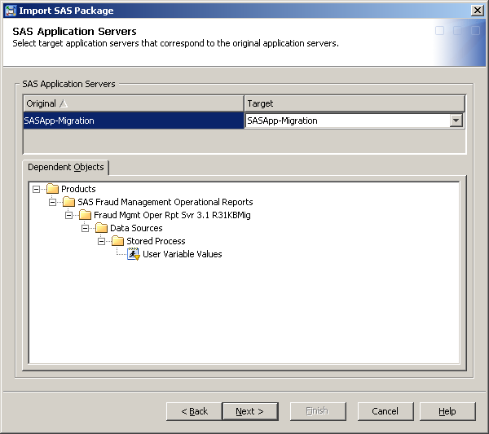

- Ensure that the two tables in Target belong to the correct rh2 library in your environment. Click Next.
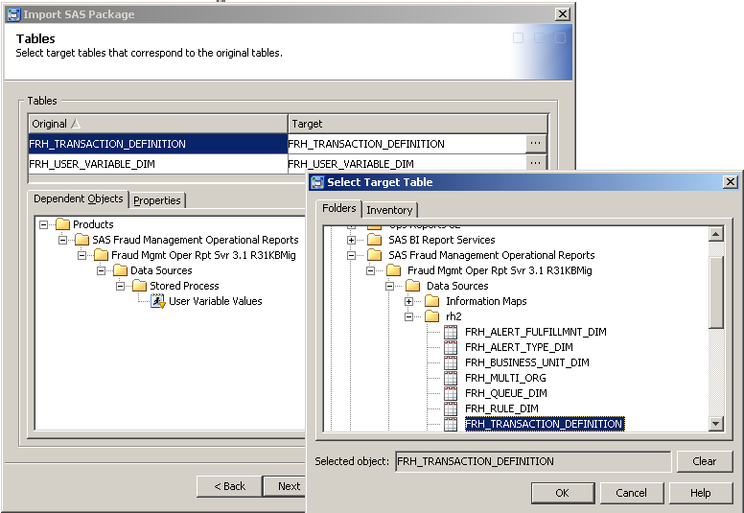

- On this screen, provide the location path where the Stored Process for the report must be copied to. Click on the Add button to add a path if the desired path does not appear in the Target drop down and then select that path in the Target drop down. Click Next.
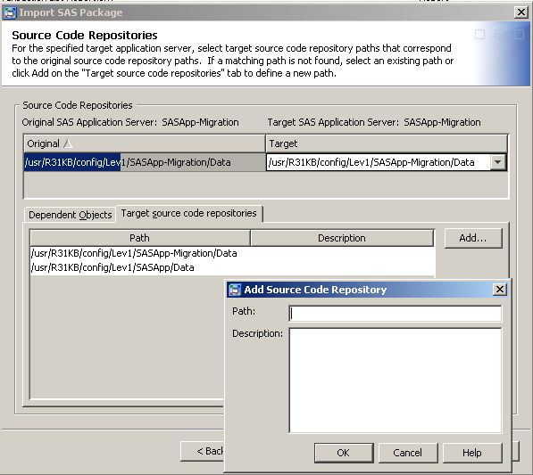

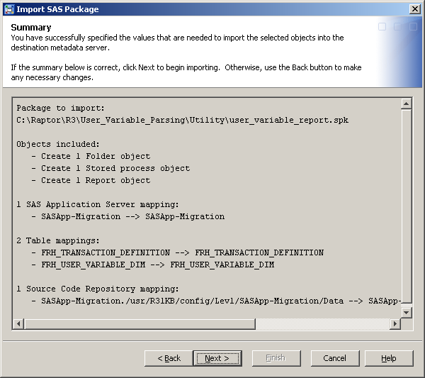
- Review the Summary for correctness.

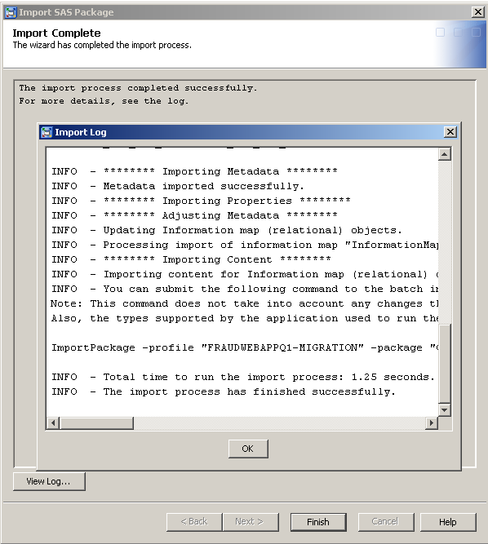
- Check the log to validate that the import completed successfully. Click OK.

Post-Installation Tasks

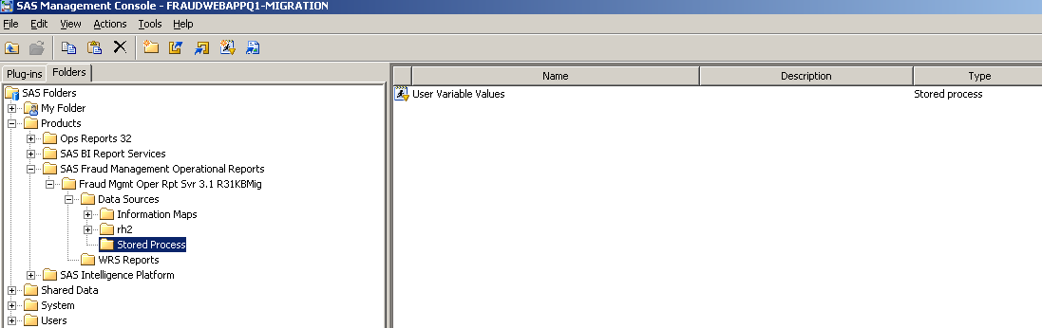
- Expand the import folder. Verify that a new, Stored Process folder is created containing the stored process, User Variable Values.

- Click on the WRS Report folder and verify that a new report, User Variable Values Report, has been added to the existing reports.
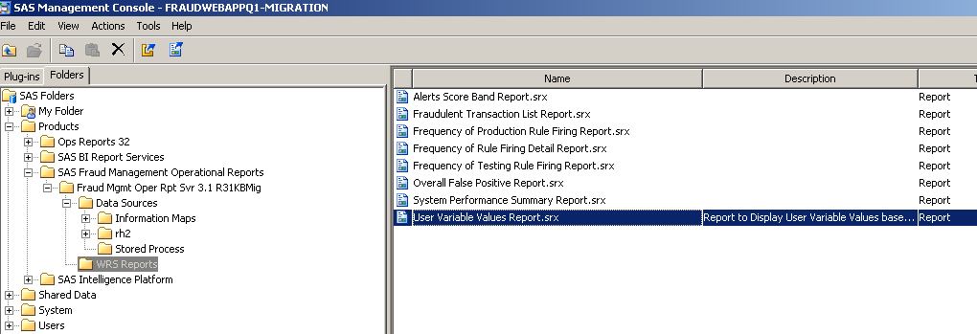

- Click on the Stored Process folder and double-click on User Variable Values to open the Stored Process Properties window.

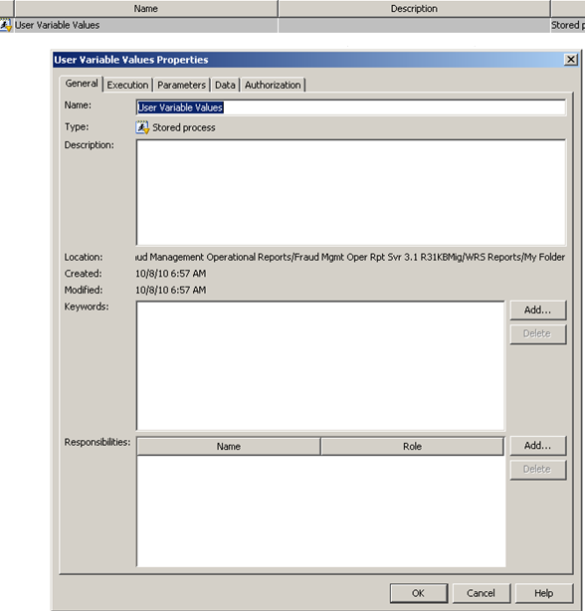

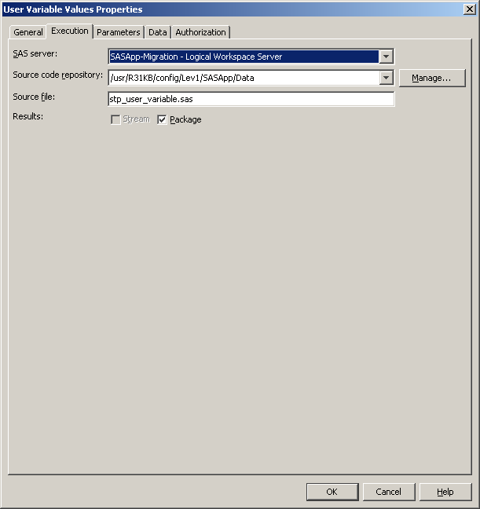
- Click on Execution tab and check that the Server, Repository and Source file information are correct. Also, verify that the Package box is checked.

- Click on the Parameters tab and expand “Package – File System …”. Click on Archive Path and click Edit.
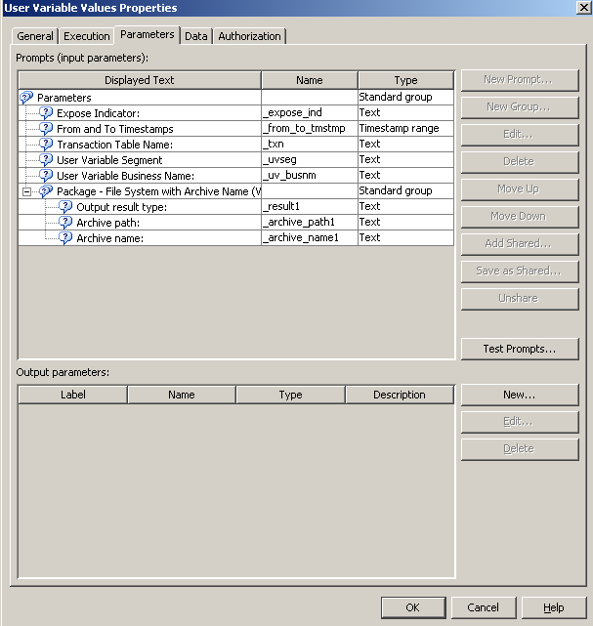

- Click on Prompt Type and Values tab and replace the Default value for path with an appropriate path where the report will create a .html file prior to display. Click OK.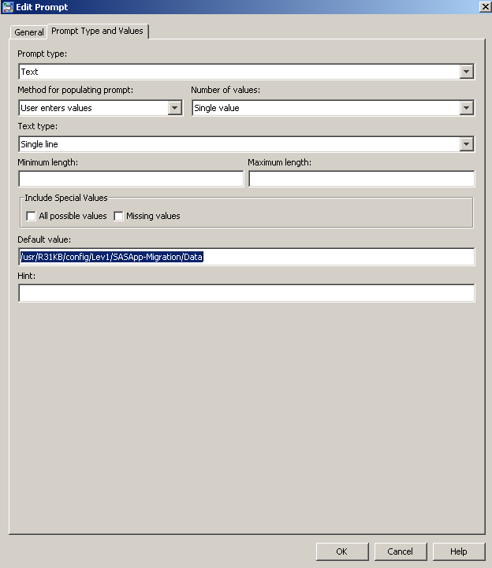

- To change the default setting of “1 hour from now” for maximum value allowed in the “To” timestamp, select the parameter, “From and To Timestamps” and click Edit. Next, click on Prompt Type and Values tab and provide the desired value for “Maximum value allowed”

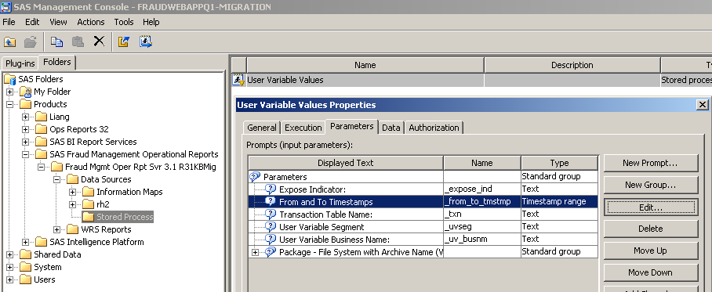

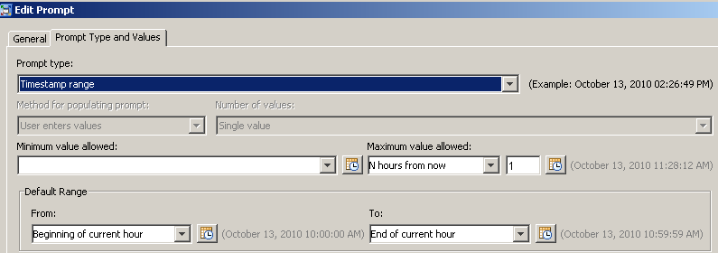

- Check that the Stored Process, stp_user_variable.sas, exists at the location specified in Step 13 of Installation Tasks.

- After executing the database patch in this hotfix, verify that the FRH_PROPERTY table In the Reporting History database contains a row for PROPERTY_NAME = ‘RPT_MAX_TXN’.

- Update PROPERTY_VALUE to change the estimated maximum number of rows to display on the report from 1000 to a value appropriate to your environment.

